TOS Complete User Guide

Tri-E Trading Operating System (TOS)
Tri-E Enterprises — Internal Operations System

A complete, illustrated walkthrough of every module — Point of Sale, Inventory,
Sales & Purchasing, Delivery & Fleet Management, Finance, HR & Payroll,
Reports, and User Administration.

For Administrators, Supervisors, Cashiers, and Staff
Documentation Version 2.0 · August 2026

Table of Contents
Right-click here and choose 'Update Field' (or press F9) to generate the Table of Contents.

1. Introduction

1.1 About Tri-E TOS
The Tri-E Trading Operating System (TOS) is an all-in-one business management platform built for Tri-E Enterprises’ trading and retail operations. It brings together every part of the business into one system:
- *Point of Sale (POS)** — fast, touch-friendly counter transactions
- *Inventory & Sales** — products, categories, customers, suppliers, sales, purchases, quotations
- *Delivery Management** — delivery tracking and driver assignment
- *Fleet Management** — company vehicles and maintenance scheduling
- *Attendance Management** — employee time tracking, leave, and biometric devices
- *Payroll** — payroll runs, compensation, and government contributions
- *Finance** — expenses, financial dashboard, and profit & loss reporting
- *Reports** — sales, inventory, aging, and driver performance analytics
- *User Administration** — users, roles & permissions, and audit logs

1.2 System Requirements
- A modern web browser — Chrome, Edge, Firefox, or Safari
- An internet connection (or local network access to the server)
- For mobile/tablet POS use: a touch-capable iOS or Android device

1.3 Technology at a Glance
Layer | Technology
Framework | Laravel 12 (PHP 8.2+)
Admin Panel | Filament v4 with Livewire v3
Access Control | Spatie Permissions + Filament Shield (role-based)
POS Terminal | Alpine.js single-page application
Database | MySQL
PDF / Reports | Laravel Dompdf, CSV / Excel export
Biometric Integration | ZKTeco time-clock devices (attendance)

2. Getting Started

2.1 Logging In
- Open your browser and go to the TOS URL provided by your administrator.
- Enter your email address and password.
- Optionally tick Remember me to stay signed in on this device.
- Click Sign in.
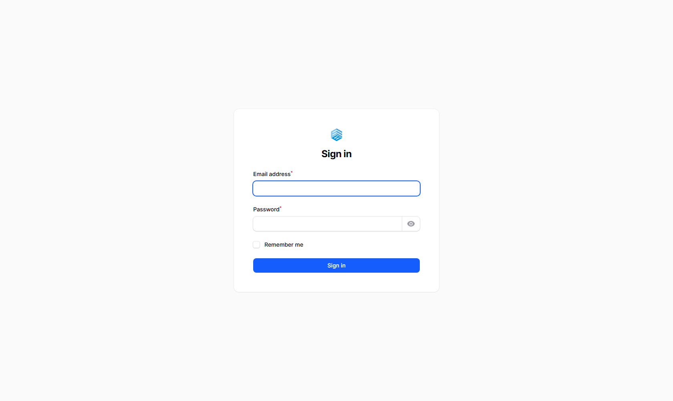
Figure 1. The Sign in screen.

ℹ If you forgot your password, contact your system administrator to have it reset.

2.2 The Home Screen (Module Launcher)
After logging in, the Home page shows a card for every module you have access to — this is the fastest way to get around the system. Each card opens straight into that module. Modules you do not have permission for simply will not appear.
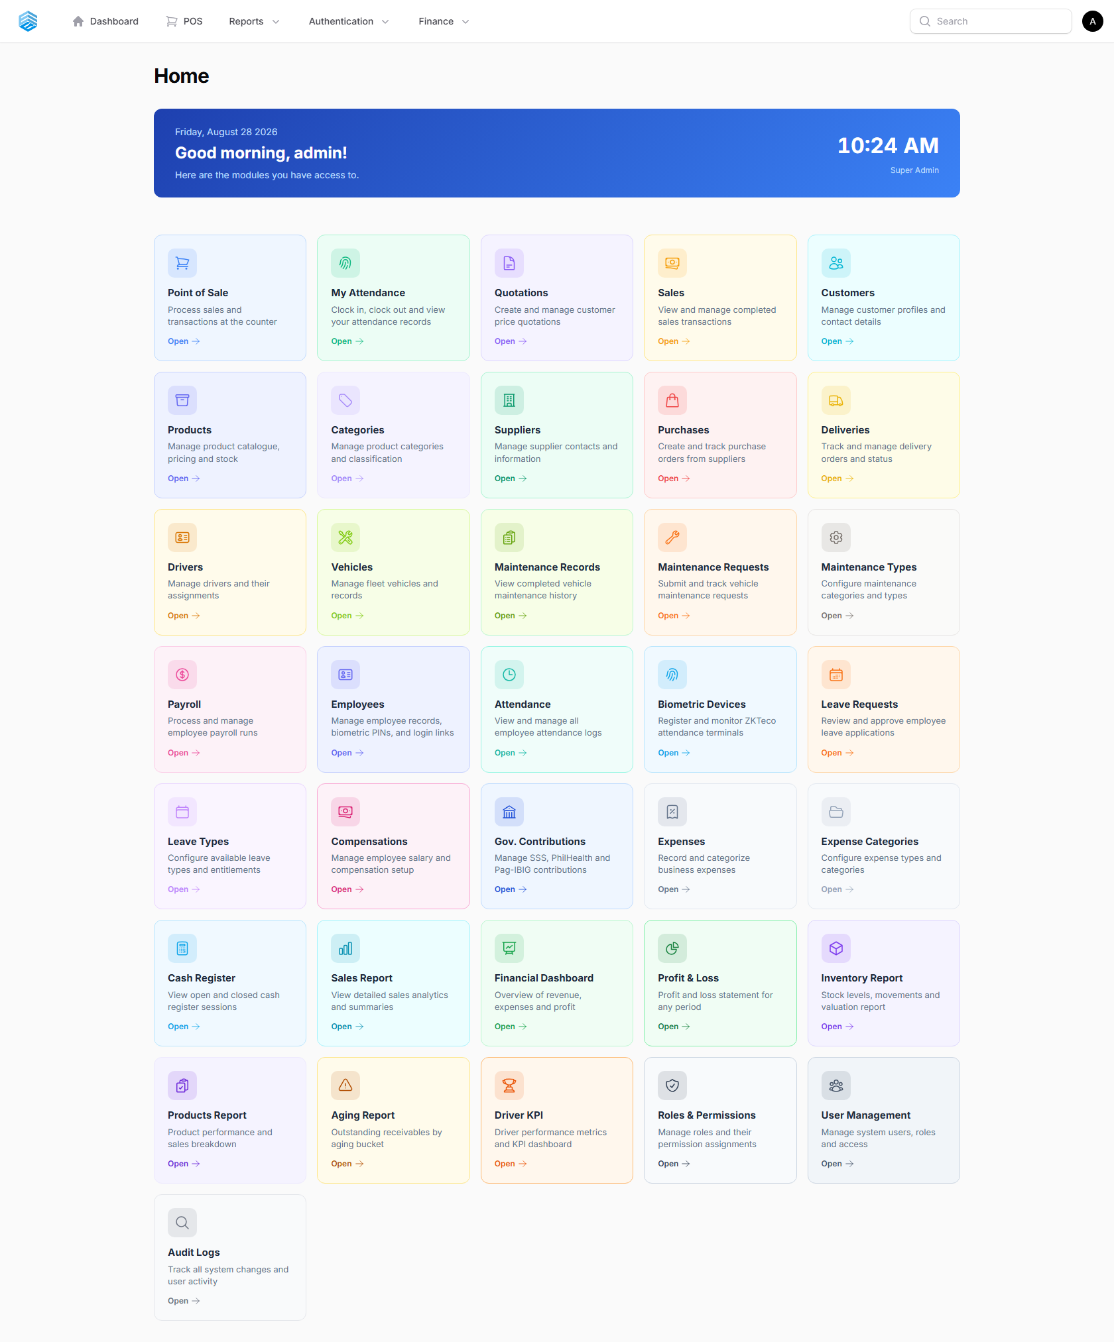
Figure 2. The Home screen — every module you can access, as a clickable card grid.

ℹ Access to each card is controlled by your assigned **role** (see Section 12.2, "Roles & Permissions"). A cashier, for example, will typically only see Point of Sale and My Attendance.

2.3 Top Navigation Bar
In addition to the Home screen, a top navigation bar is always visible with quick links to:
Menu | Contains
Dashboard | The business metrics dashboard (Section 3)
POS | Opens the Point of Sale terminal directly
Reports ▾ | Inventory In/Out, Products, Sales, Supplier Price Comparison, Daily Transaction, Driver KPI, Aging Report
Authentication ▾ | Roles & Permissions
Finance ▾ | Financial Dashboard, Profit & Loss
Search (top right) | Global search across the system
Avatar (top right) | Your Profile and Sign out

2.4 User Roles
Access in TOS is role-based. The system ships with these common roles (your administrator can create additional custom roles at any time):
Role | Typical Access
Super Admin | Full, unrestricted access to every module and setting
Admin | Broad administrative access across modules
Manager / Ops Supervisor | Operational modules — sales, inventory, deliveries, reports
Cashier | Point of Sale, plus basic sales and customer lookup
Sales Rep | Customers, quotations, and sales
Warehouse Clerk | Products, categories, purchases, inventory
Driver | My Attendance and assigned deliveries only

3. Dashboard
The Dashboard (click Dashboard in the top nav) gives an at-a-glance view of overall business health.
- *Financial Overview** — Monthly Revenue, Monthly Profit, Monthly Expenses, and Profit Margin, each compared against last month with a trend indicator.
- *Store Overview** — quick totals for Products, Sales, Total Sales Price, Purchases, and Low Stock items.
- *Overdue Alerts** — Accounts Receivable (unpaid customer invoices) and Accounts Payable (unpaid supplier bills) that have passed their due date, listed individually with days overdue.
- *Collection & Payment Reminders** — invoices due today or within the next 7 days, so you can plan collections proactively.
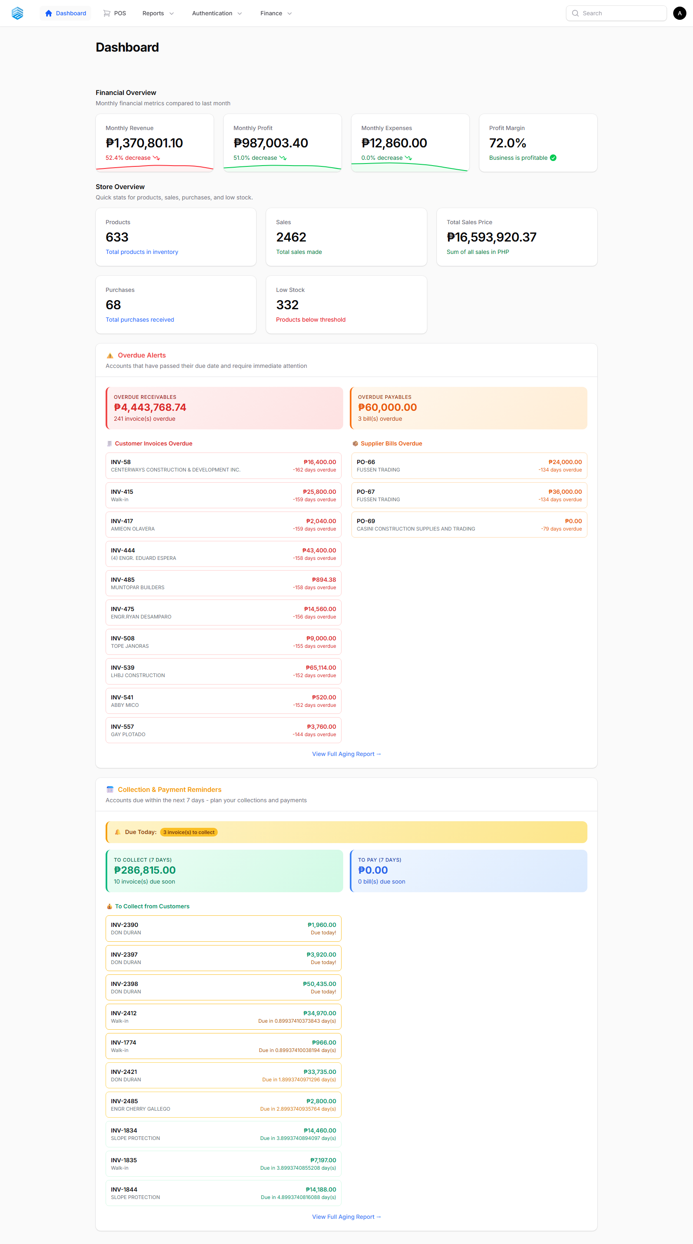
Figure 3. The Dashboard — financial overview, store stats, and overdue-account alerts.

ℹ Clicking any invoice or bill line on the dashboard opens that record directly. Use **View Full Aging Report** to see the complete overdue breakdown (Section 11.7).

4. Point of Sale (POS)
The POS is a fast, touch-friendly, single-page terminal for processing counter sales. It works on desktop, tablet, and mobile, and runs without full-page reloads — a session can stay open all day. Open it from the POS link in the top nav, the Point of Sale card on the Home screen, or by browsing directly to `/pos`.
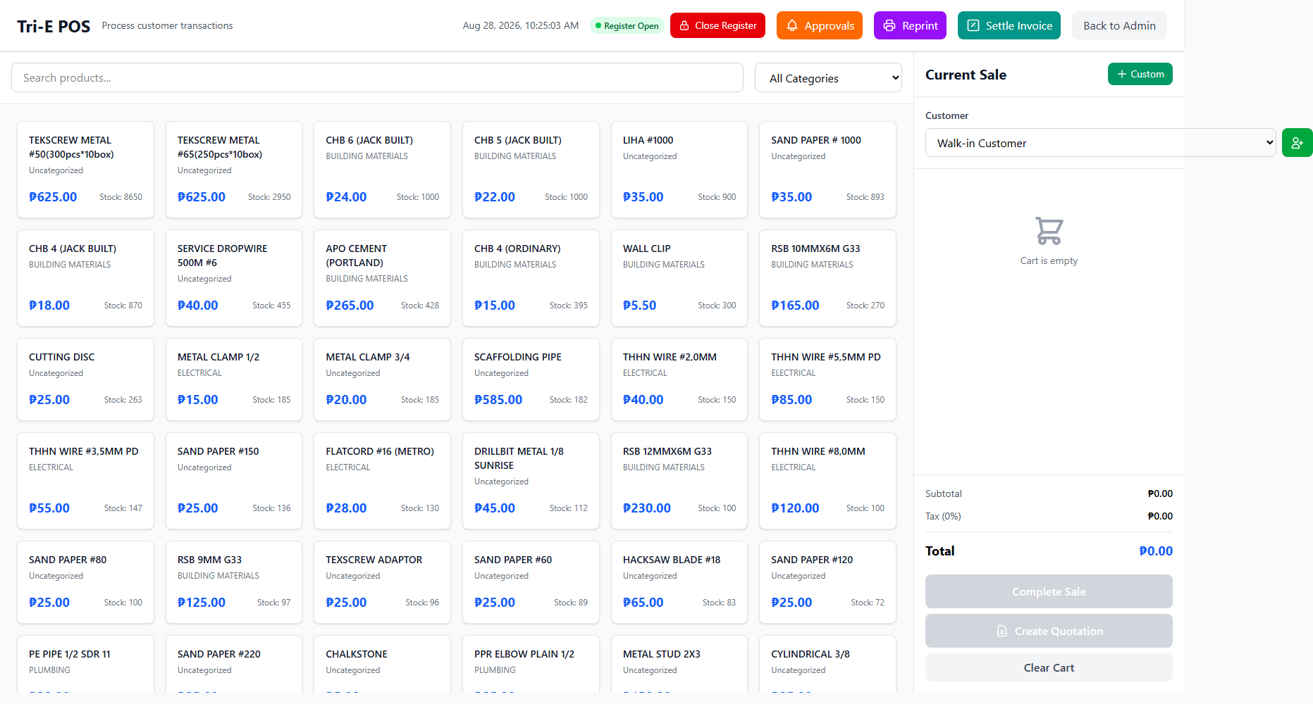
Figure 4. The POS terminal — product grid on the left, current sale on the right.

4.1 Opening the Cash Register
You must open the register before any sale can be processed.
- When you first open the POS, you will be prompted for an Opening Amount.
- Count the physical cash in the drawer and enter the total.
- Click Open Register.
ℹ Only one open register session per user is allowed at a time. The register bar at the top of the POS shows a green **Register Open** badge once active.

4.2 Browsing and Adding Products
- Browse product cards, sorted by stock level, or use the search bar to find a product by name.
- Use the category dropdown to narrow the list.
- Click a product card to add it — for weight, volume, or length units (kg, g, L, mL, m, ft) a quantity modal appears first; all other units are added directly with a quantity of 1.
- Products with zero stock are marked out-of-stock and cannot be added.
- Use the green + Custom button to add a manual line item (name, unit, price, quantity) for anything not in the catalogue — manual items do not affect inventory.

4.3 Managing the Cart
Action | How
Increase / decrease quantity | Use the + / − buttons on the cart line
Type a quantity directly | Click the quantity number and type a new value
Apply a discount | Enter a ₱ amount on the line; tick "flat total" to make it a fixed discount for the whole line instead of per piece
Remove an item | Click the trash / × icon on that line
Clear the cart | Click Clear Cart — a confirmation prompt appears first

ℹ The cart total updates live. A discount can never make a line total go below zero.

4.4 Selecting a Customer
- Search for an existing customer by name in the Customer field, or click the + icon to add a new customer on the spot (name, phone, email, address) — the new customer is auto-selected after saving.
- Leave the field on Walk-in Customer for anonymous sales.

4.5 Processing a Payment
- Review the cart total, then click Charge (Complete Sale).
- Select a payment method: Cash, Bank Transfer, Check, Credit Card, GCash, or Maya.
- For Cash, enter the amount received — the system calculates the change automatically.
- Optionally add a flat Delivery Fee, applied on top of the discounted item total.
- Optionally toggle Add Payment Terms for a credit sale (see 4.6 below).
- Click Confirm Payment.
The payment modal breaks the total down as:
Line | Meaning
Items Total | Raw subtotal — unit price × quantity, before discounts
− Discount | Sum of all per-item discounts (only shown if greater than zero)
+ Delivery Fee | Optional flat fee (only shown if greater than zero)
= Grand Total | What the customer actually pays

ℹ On confirmation: inventory is decremented for every non-manual item, the register totals update (for immediately-paid sales only), and a success screen with receipt print options appears.

4.6 Payment Terms (Credit Sales)
Use payment terms only for trusted customers with an approved credit arrangement.
- In the payment modal, toggle on Add Payment Terms.
- Select the credit period: 5, 10, 15, 30, or 60 days.
- The Due Date is calculated automatically.
- Choose a payment method and click Confirm Payment.
Condition | Payment Status | Counted in Register Totals?
No payment terms (cash, card, GCash, etc.) | paid | Yes
Payment terms applied | unpaid | No — until collected

⚠ Never apply payment terms to an instant/cash payment. Terms are only for genuine credit arrangements — the sale is excluded from cash totals until it is marked paid (Section 5.5).

4.7 Printing Receipts
Receipt Type | Use When
Delivery Receipt | The order will be delivered — includes driver / receiver signature lines
Pick Up Receipt | The customer collects at the counter — includes released-by / picked-up-by signature lines

ℹ Receipts print two copies side by side on A4 landscape — an Office Copy and a Customer's Copy — separated by a cut line.

4.8 Reprinting a Past Receipt
Click Reprint in the POS header to see the last 50 sales, most recent first. Search by receipt number or customer name, then reprint in either format.

4.9 Creating a Quotation
- Build the cart as normal and optionally select a customer.
- Click Create Quotation instead of Complete Sale.
- Set the validity period (7–90 days, default 30) and add optional notes.
- Click Create & Print — a printable quotation opens in a new window.
Once created, an admin with the `approve_quotation` permission is notified by email and can approve or reject it. An approved quotation can be converted back into a sale by re-opening the POS from the quotation link — the cart is pre-filled with its items.
Status | Meaning
Pending | Awaiting admin approval
Approved | Ready to convert to a sale
Rejected | Declined by admin
Converted to Sale | Already completed as a sale
Expired | Validity period has passed

4.10 Settling an Invoice
Use Settle Invoice in the POS header to record a payment against an existing outstanding (credit/term) sale without creating a new transaction, and print a payment receipt.

4.11 Closing the Cash Register
- Click Close Register.
- Physically count all cash in the drawer and enter the Closing Amount.
- Add any notes (e.g., unusual transactions) if needed.
- Click Close Register to confirm.
The system calculates the expected amount (opening cash + cash sales collected) and shows the discrepancy (positive = overage, negative = shortage). A PDF session report downloads automatically, containing the summary and a full list of every sale processed in the session.
ℹ Re-download a past closure report anytime from the Cash Register list (Section 5.8).

5. Inventory & Sales
This module group covers the product catalogue, customers, suppliers, and every sales and purchasing transaction. Open any of these from the Home screen.

5.1 Products
The product catalogue is the source of truth for everything sold through the POS.
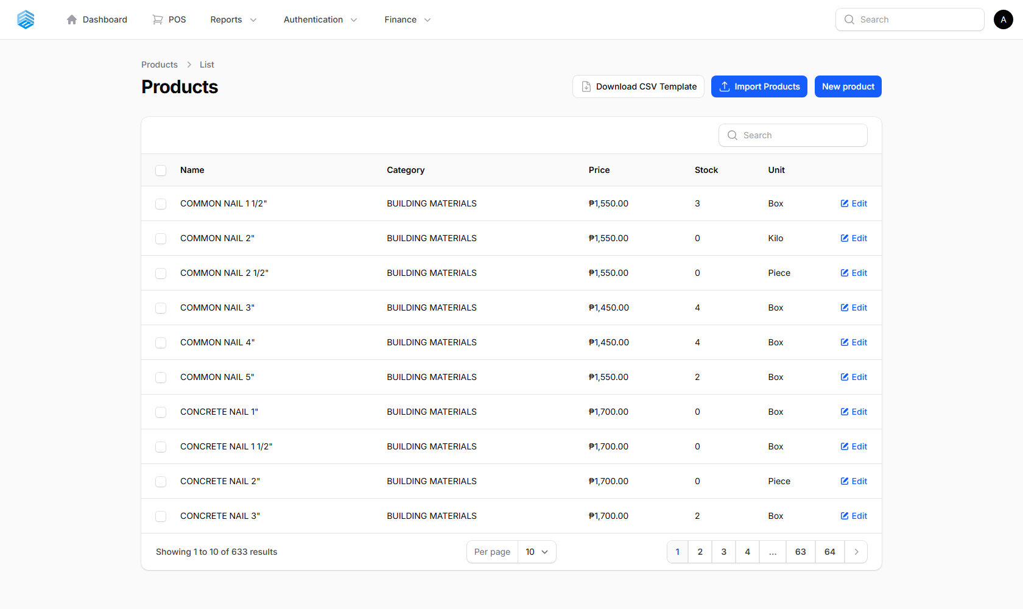
Figure 5. The Products list — searchable, with category, price, stock, and unit.

Adding a Product
- Click New product.
- Fill in Name, Category, Supplier, Price (selling price), and Stock.
- Choose the Unit (see the unit table below).
- Optionally configure Additional Sellable Units (e.g. sell a hose per Meter but also per Roll) and Supplier Base Prices (record what each supplier charges, for price comparison on purchase orders).
- Click Create.
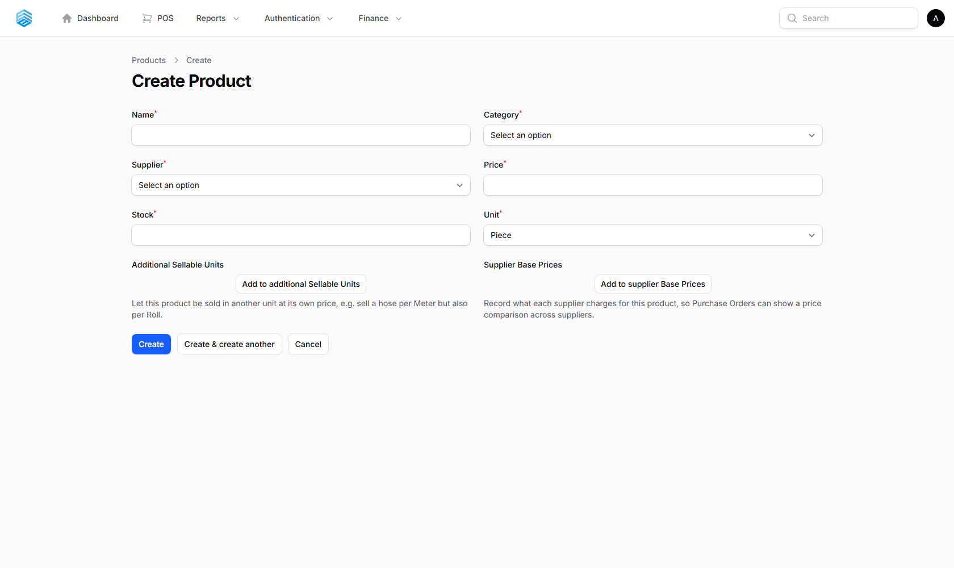
Figure 6. The Create Product form.

Key Fields
Field | Description
Price / Cost Price | Selling price and purchase cost — used to calculate profit margin automatically
Unit | Piece, Bag, Box, Bundle, Knot, Tube, Kilo, Gram, Liter, Milliliter, Meter, Foot, Cubic Meter
Profit Margin / Profit per Unit | Calculated automatically from Price and Cost Price (defaults to 70% margin if cost is not set)

ℹ Stock levels are updated automatically through **Purchases** (Section 5.6) — do not edit stock manually.

5.2 Categories
Categories organise products for easier browsing in the POS product grid and reports. Simply add a Name for each category you need.
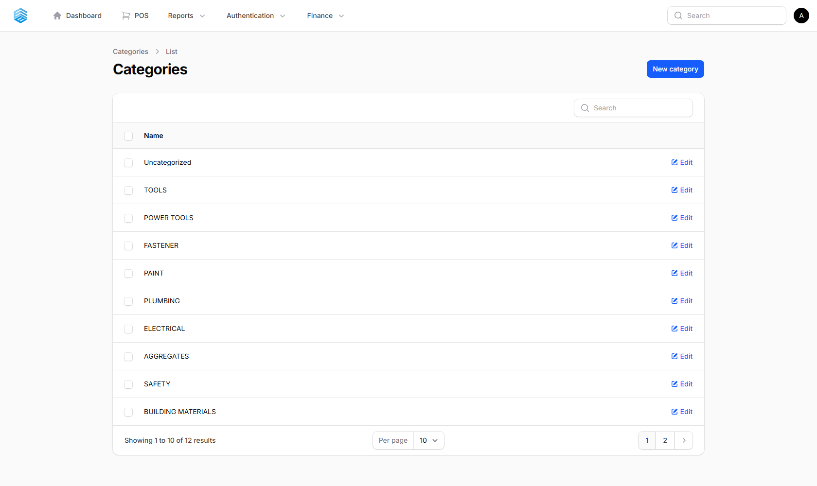
Figure 7. The Categories list.

5.3 Suppliers
Suppliers are the vendors you purchase stock from.
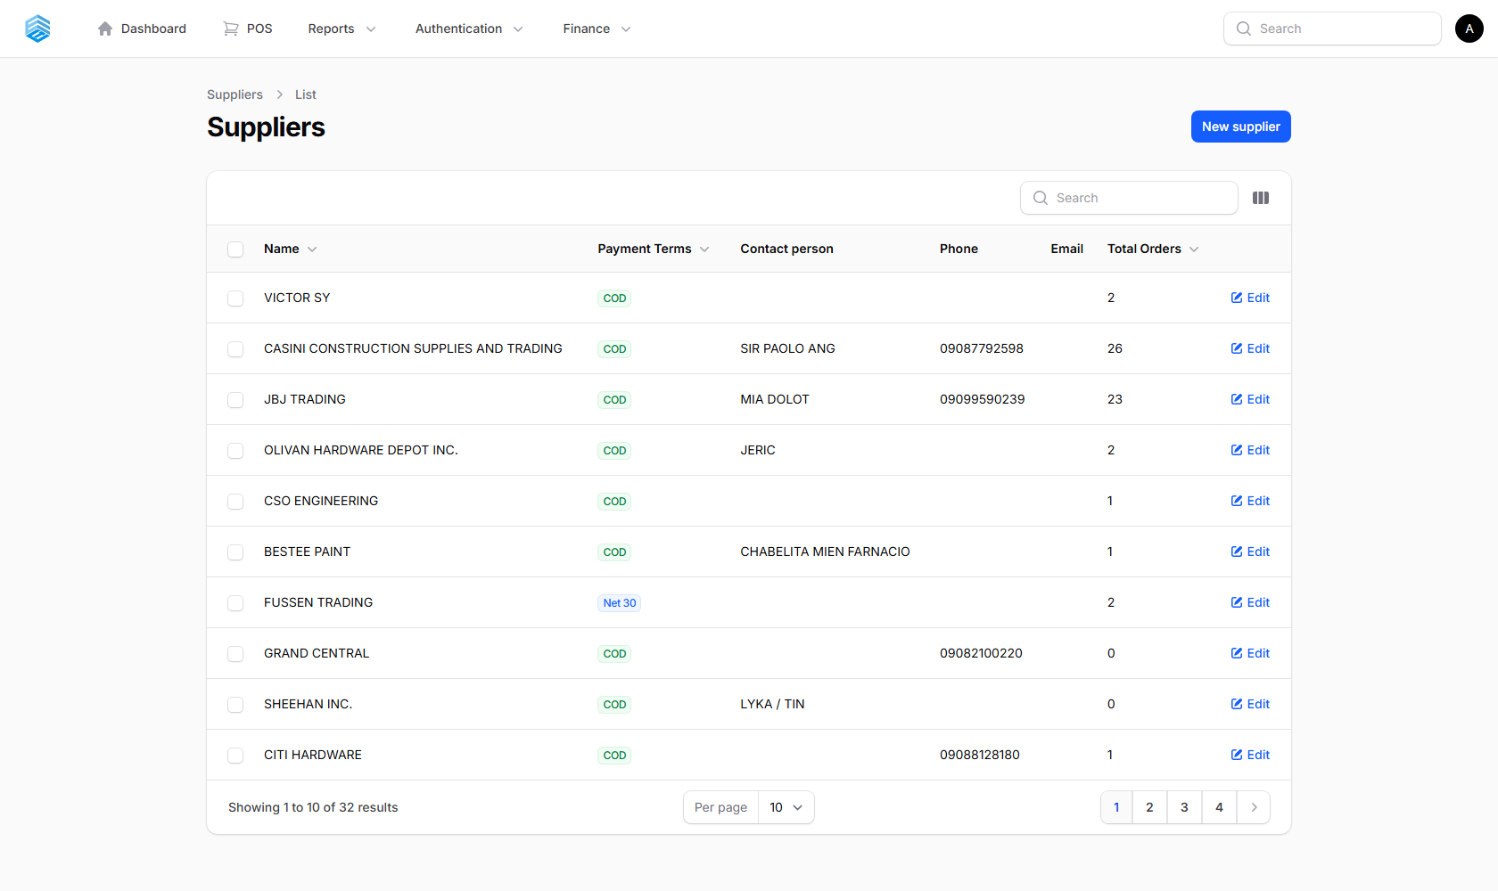
Figure 8. The Suppliers list.

Key Fields
Field | Description
Contact Person / Phone / Email / Address | Supplier contact details
Payment Term Days | 0 = COD (cash on delivery); otherwise Net X days — used to auto-calculate the due date on purchases from this supplier

5.4 Customers
Customer profiles are shared across Sales, Quotations, and Deliveries.
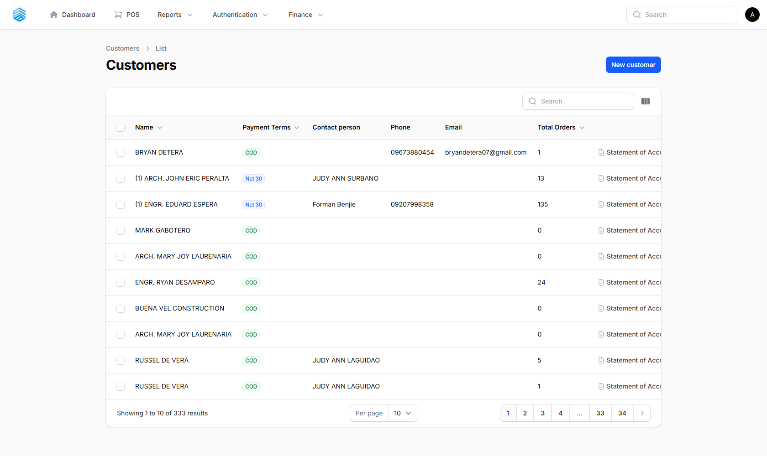
Figure 9. The Customers list.

Adding a Customer
- Click New customer.
- Enter Name (required) plus Company, Phone, Email, and Address as available.
- Set Payment Term Days if this customer is allowed to pay on credit.
- Click Create.
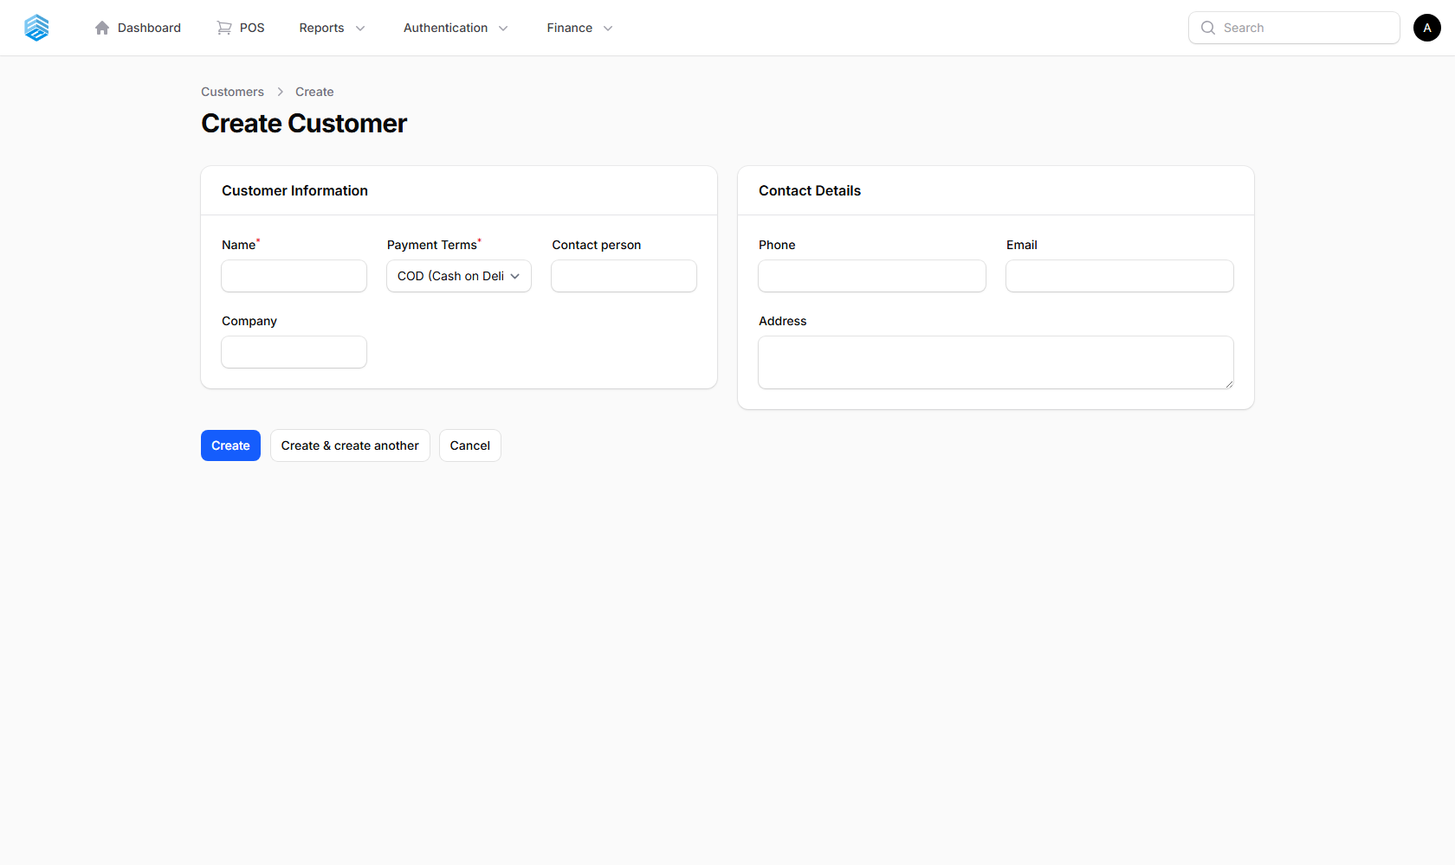
Figure 10. The Create Customer form.

ℹ Customers can also be added on the fly directly from the POS without leaving the terminal (Section 4.4).

5.5 Sales
Every completed transaction — from the POS or created manually — appears here.
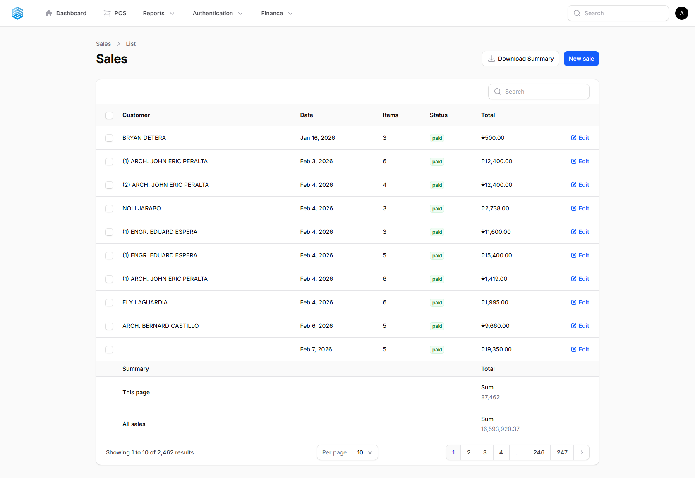
Figure 11. The Sales list — customer, date, item count, payment status, and total.

Creating a Manual Sale
- Click New sale.
- Select a customer (or leave blank for walk-in).
- Add products and quantities, and set the payment status.
- Click Create.
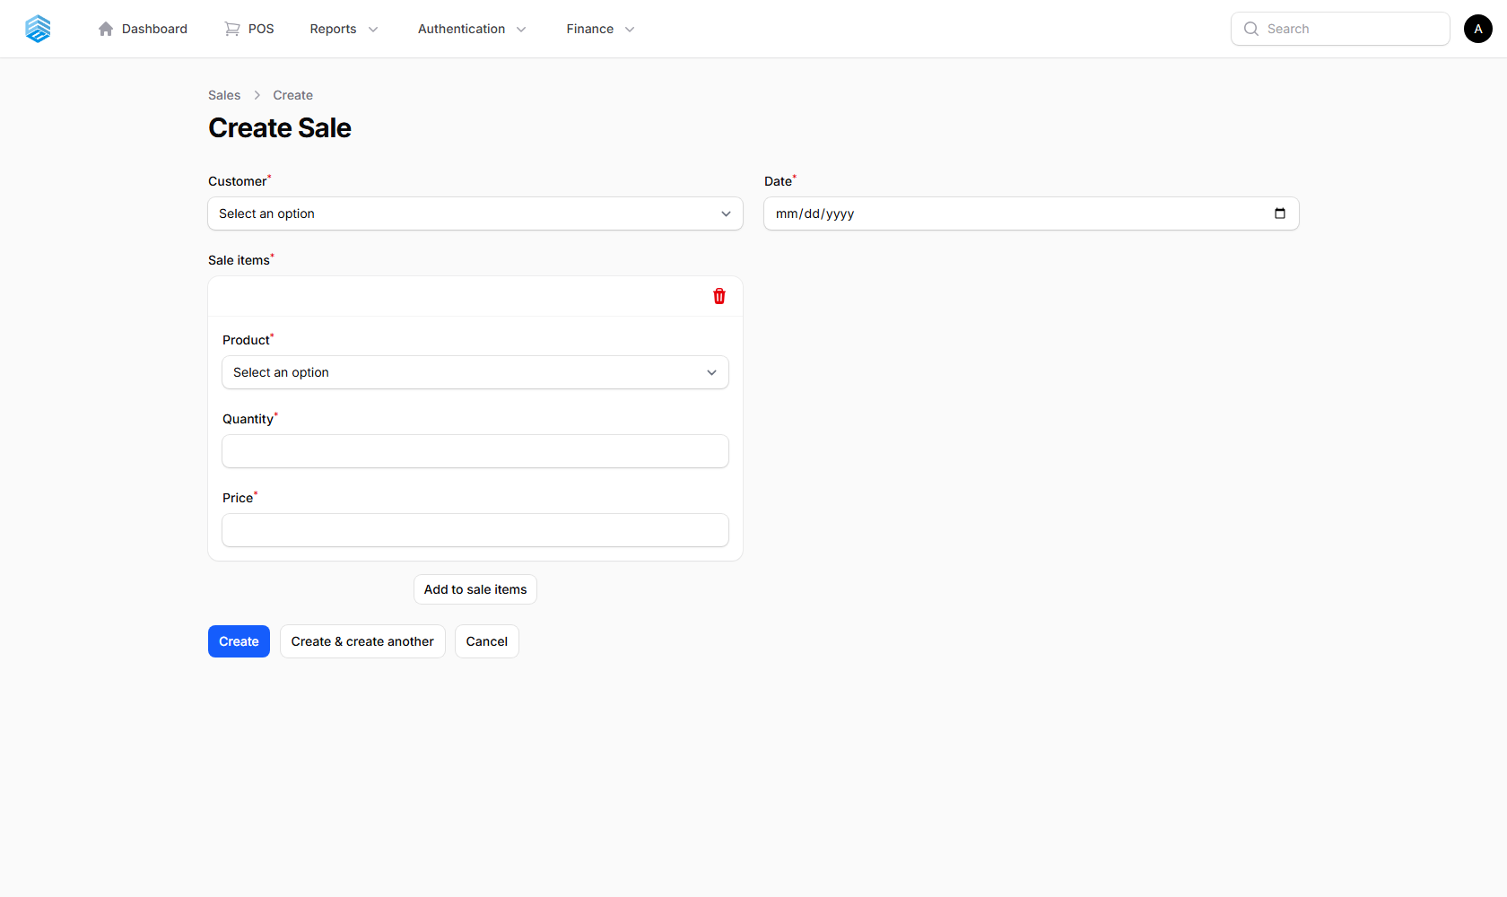
Figure 12. The Create Sale form.

Statuses
Status | Meaning
paid (green) | Payment has been fully collected
partial (yellow) | Part of the amount has been collected
unpaid (red) | No payment collected yet — a credit/term sale

ℹ Most sales should be processed through the POS for the full discount, payment, and receipt experience.
ℹ A **Mark as Paid** action appears on unpaid credit/term sales — click it, confirm the amount, and the sale is marked paid immediately.
ℹ Use **Download Summary** to export a CSV of sales totals grouped by date, for any period (Today, This Week, This Month, custom range, etc.).

5.6 Purchases
Purchases record stock received from suppliers and automatically update inventory.
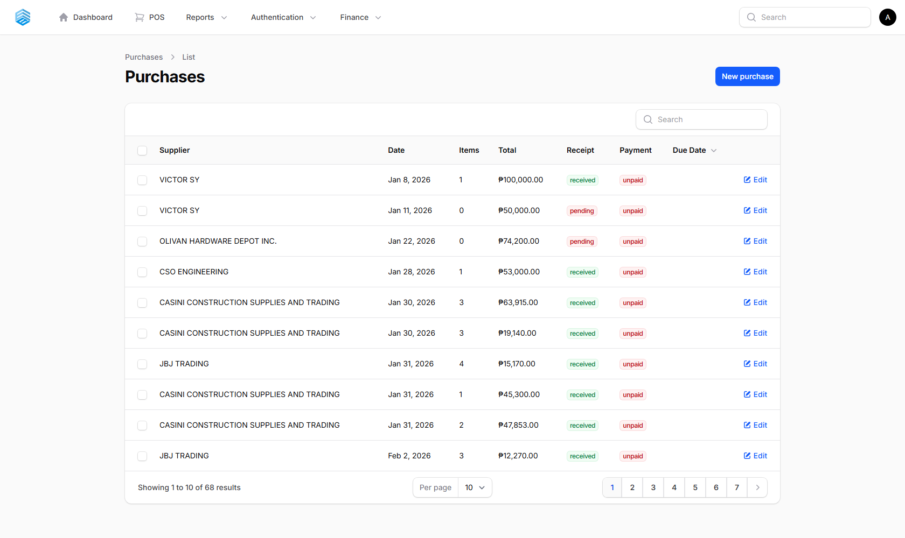
Figure 13. The Purchases list.

Creating a Purchase
- Click New purchase.
- Select the Supplier.
- Add purchase items — product, quantity ordered, and unit price.
- Click Create.
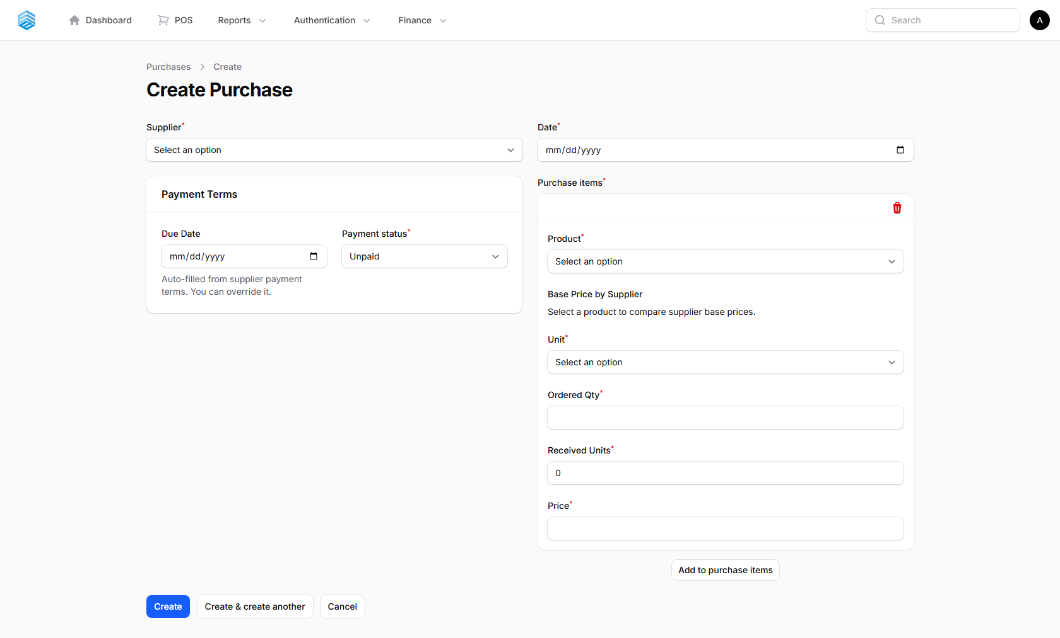
Figure 14. The Create Purchase form.

Statuses
Status | Meaning
Pending | No items received yet
Partial | At least one item received, but not all
Received | All ordered items fully received

ℹ When a supplier can only fulfil part of an order, record the actual **quantity received** per line — inventory increases by exactly that amount. The amount owed is always based on the full ordered quantity, regardless of how much has arrived.
ℹ The due date is calculated automatically from the supplier’s payment terms.

5.7 Quotations
Quotations are price proposals sent to a customer before a sale is confirmed — created either here or from the POS (Section 4.9). Open a quotation to Approve, Reject, or print it; an approved quotation can be converted into a sale from the POS.
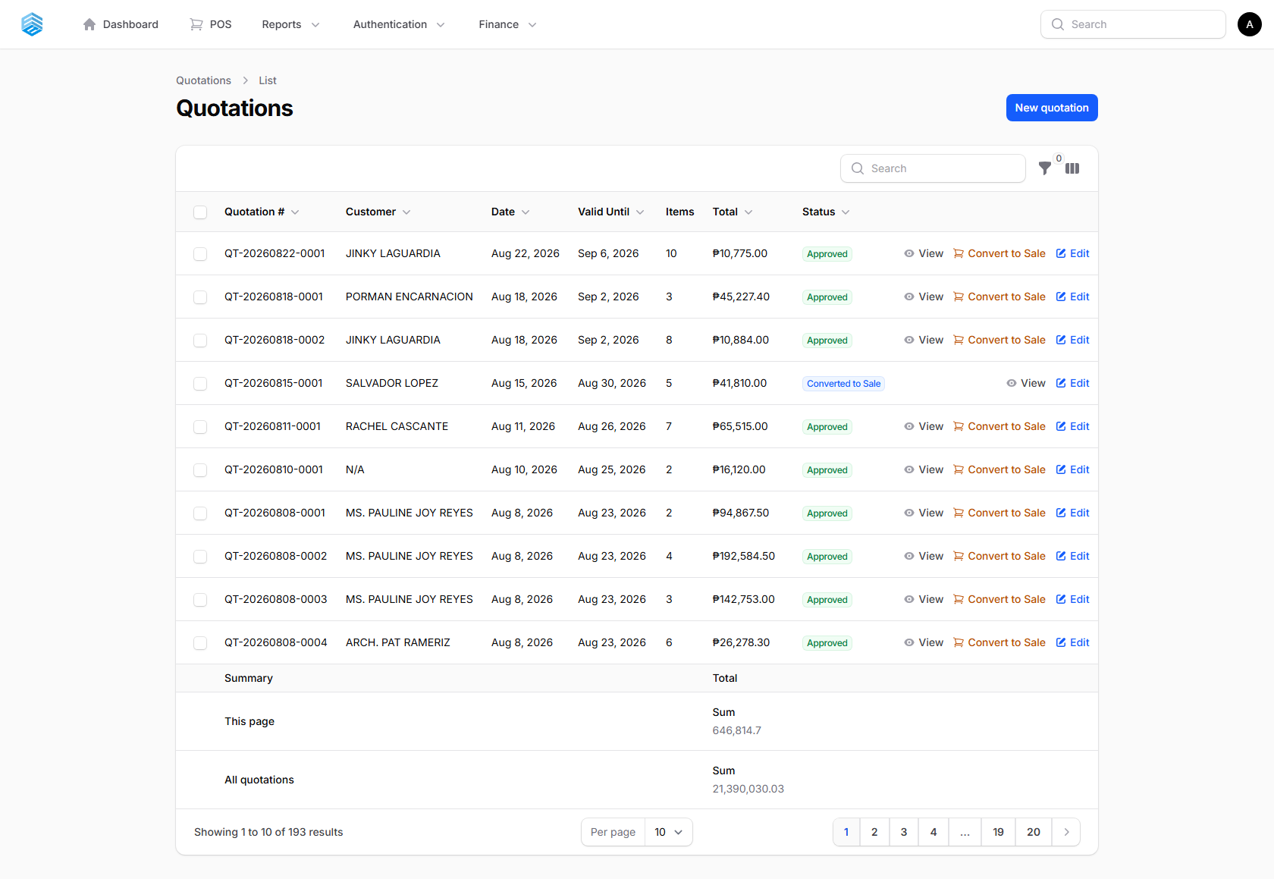
Figure 15. The Quotations list.

5.8 Cash Register
A full history of every cash register session — opening amount, closing amount, total sales, and any discrepancy. Open a session to re-download its PDF closure report.
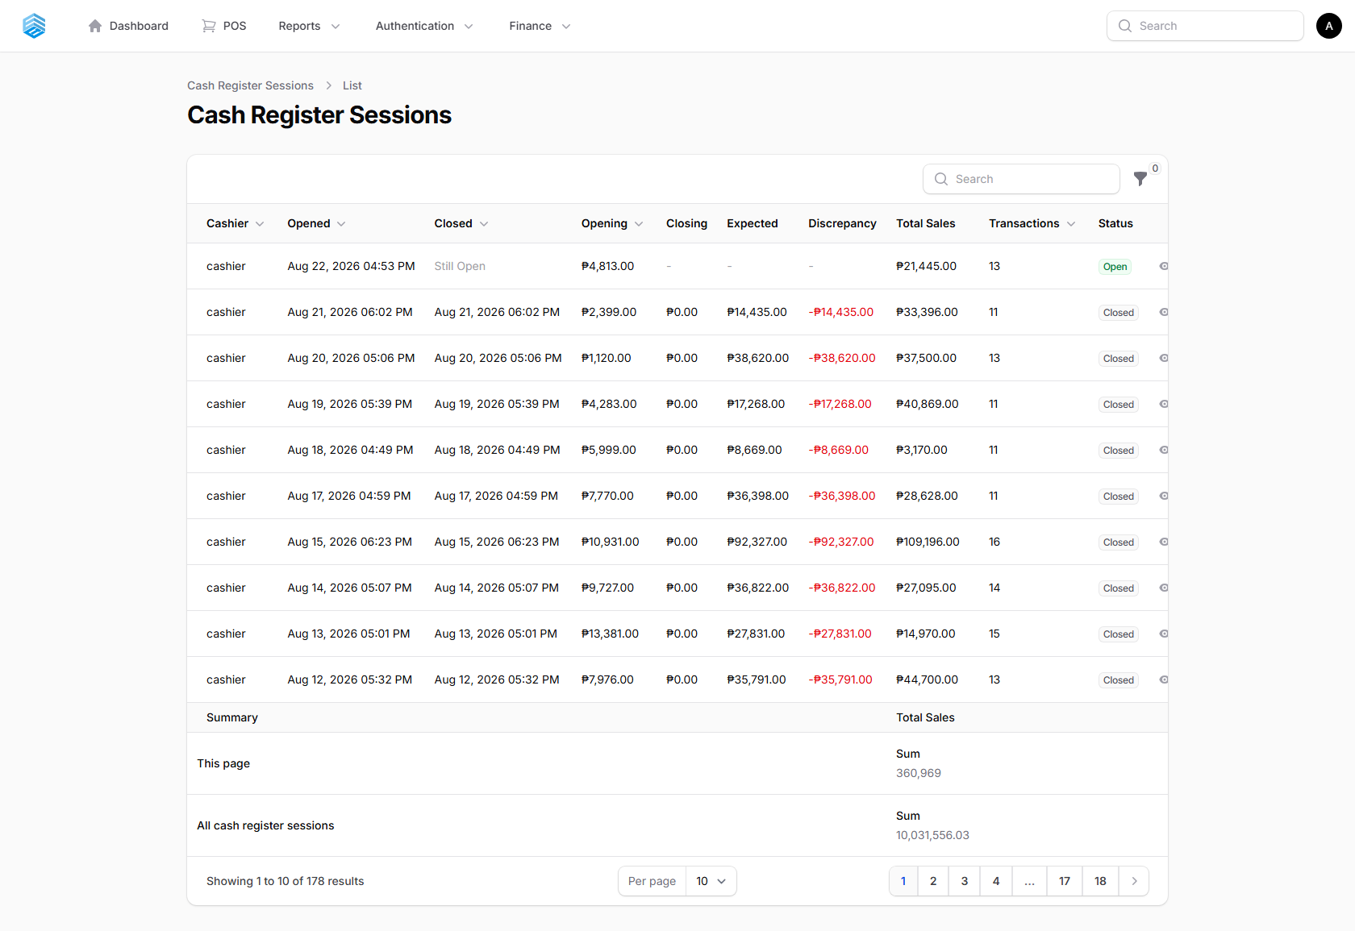
Figure 16. The Cash Register Sessions list.

6. Delivery Management
Track the delivery of orders to customers, from assignment to drop-off.

6.1 Deliveries
A delivery is linked to a completed sale.
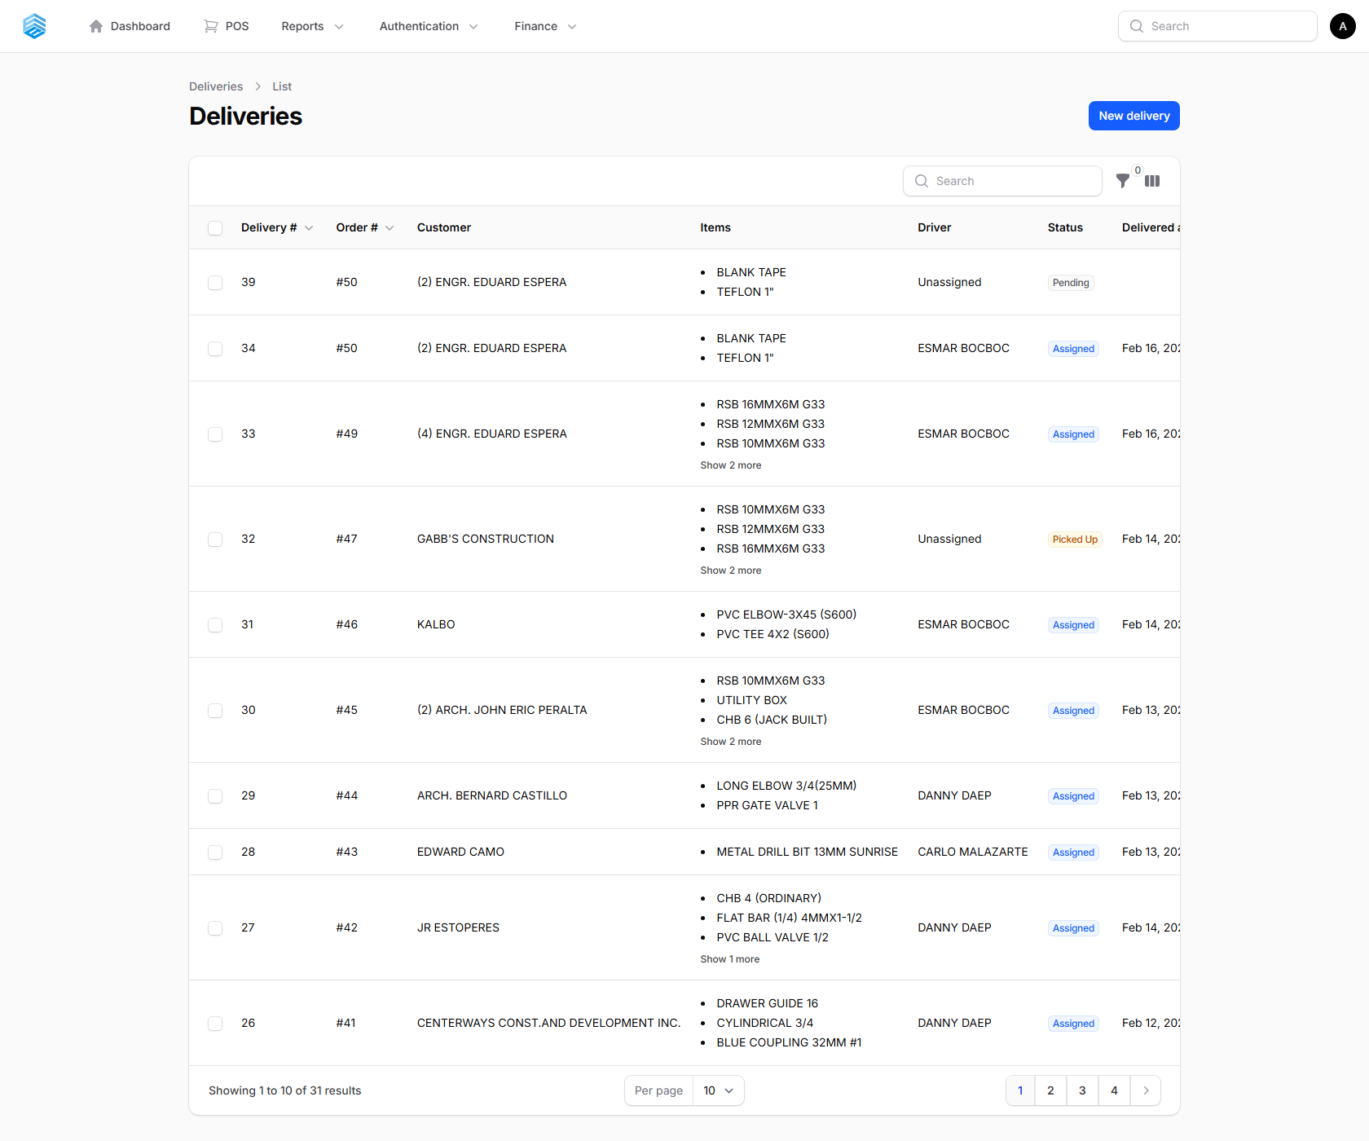
Figure 17. The Deliveries list.

Creating a Delivery
- Click New delivery.
- Select the Sale this delivery is for and assign a Driver.
- Enter the delivery Address, distance, and any notes.
- Click Create.
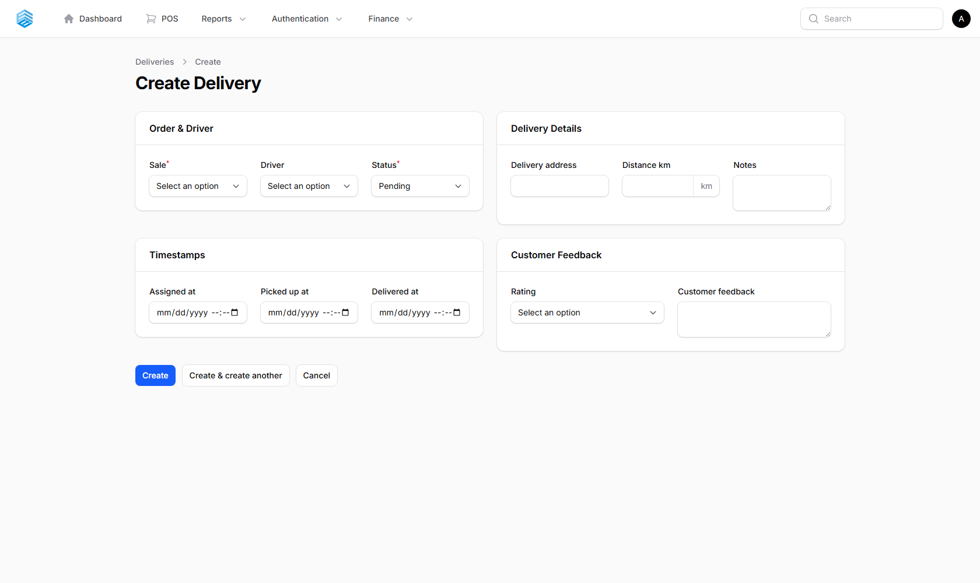
Figure 18. The Create Delivery form.

Statuses
Status | Meaning
Pending | Delivery created, awaiting driver assignment
Assigned | Driver has been assigned
Picked Up | Driver has collected the goods
In Transit | Goods are on the way
Delivered | Successfully delivered to the customer
Failed | Delivery attempt was unsuccessful
Returned | Goods were returned to the warehouse

ℹ Open a delivery and use **Print Receipt** to generate the driver’s delivery document with signature lines. Customers can also leave a 1–5 star rating and feedback.

6.2 Drivers
Manage delivery drivers and see their performance at a glance.
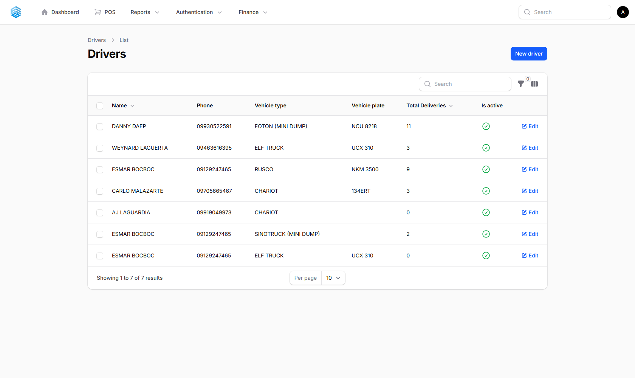
Figure 19. The Drivers list.

Key Fields
Field | Description
Name / Phone / License Number | Driver identification and contact details
Active Status | Inactive drivers are hidden from delivery assignment
Delivery Count / Average Rating / Success Rate | Calculated automatically from completed deliveries

7. Fleet Management
Track and maintain the company vehicle fleet, from acquisition to scheduled servicing.

7.1 Vehicles
Every company vehicle, with its maintenance history rolled up automatically.
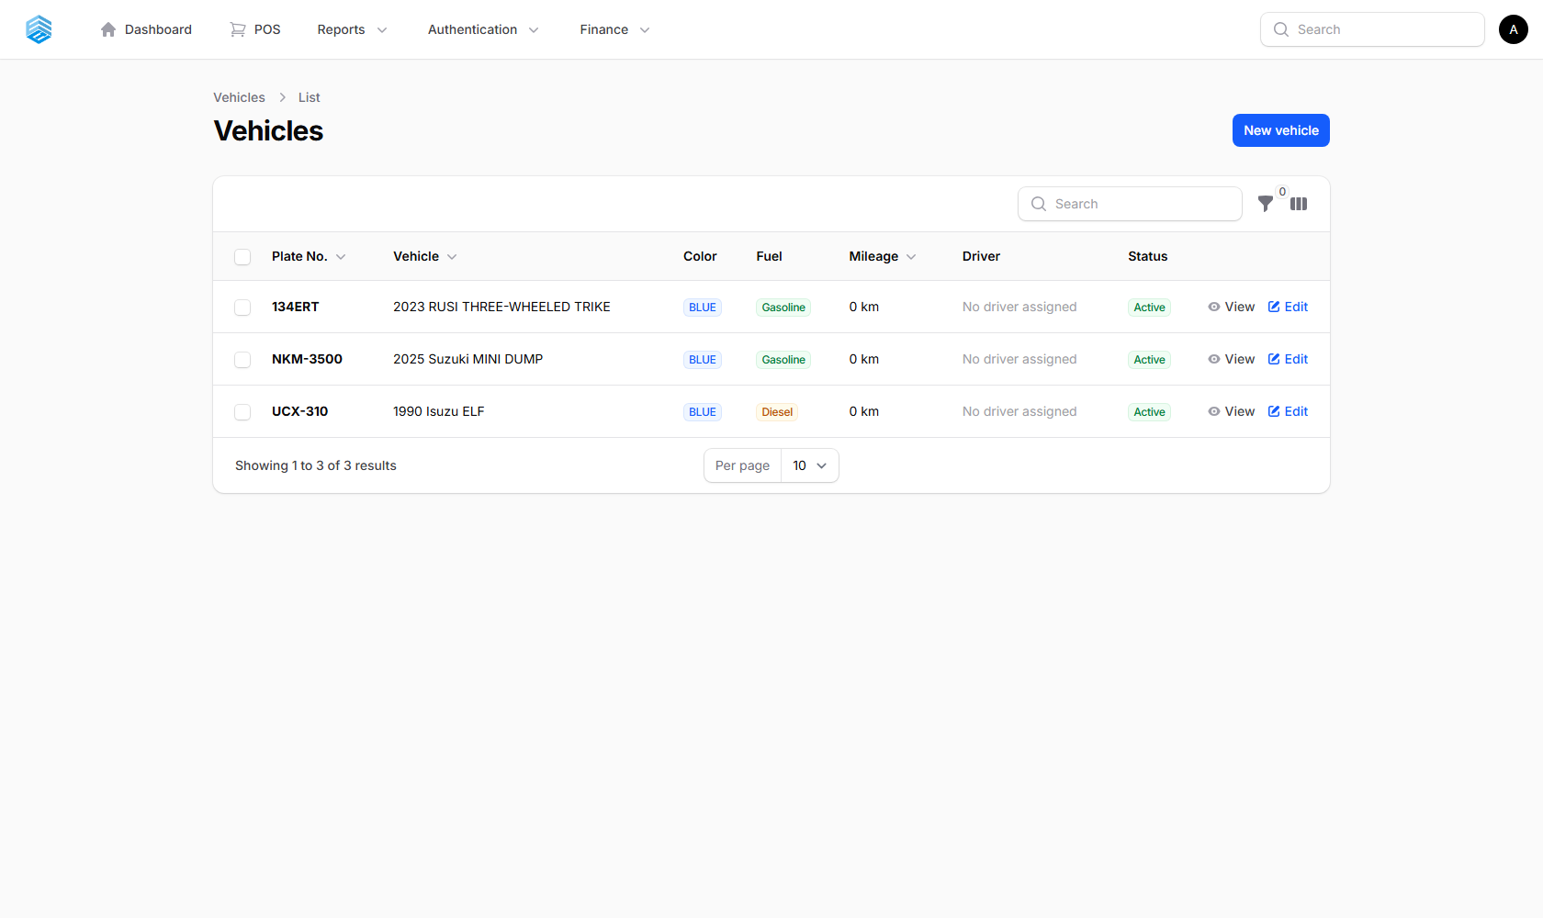
Figure 20. The Vehicles list.

Adding a Vehicle
- Click New vehicle.
- Enter the Plate Number (unique), Make, Model, Year, VIN, and Engine Number.
- Set Fuel Type, Transmission, Current Mileage, and optionally assign a Driver.
- Click Create.
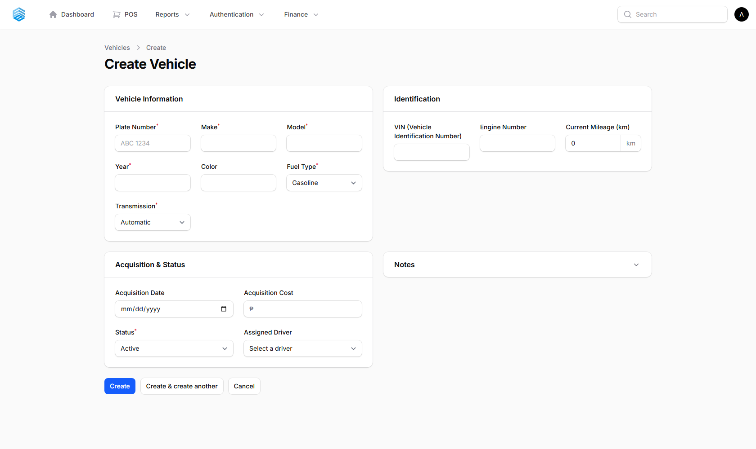
Figure 21. The Create Vehicle form.

Key Fields
Field | Description
Status | Active / Maintenance / Inactive / Sold
Total Maintenance Cost / Last Maintenance Date | Calculated automatically from service records
Maintenance Due | Flagged automatically when mileage or time exceeds the next-service threshold

7.2 Maintenance Types (Service Types)
Define the categories of maintenance work performed on vehicles — e.g. Oil Change, Tire Rotation, Brake Service — including the recommended interval in kilometres and/or months.
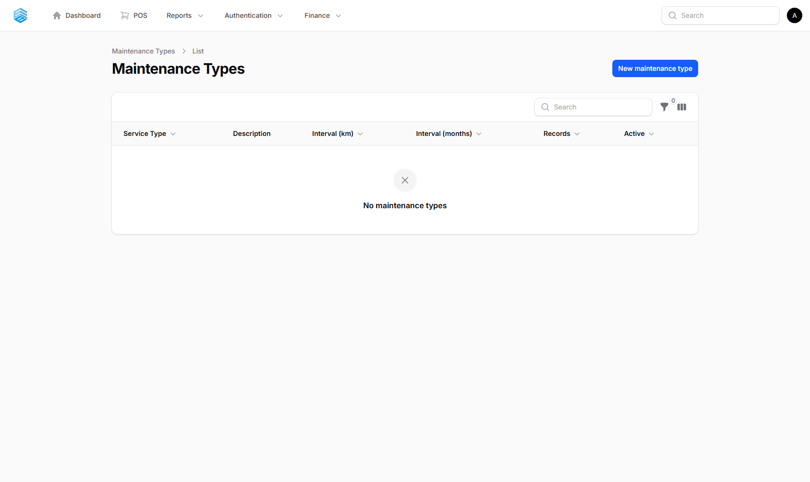
Figure 22. The Maintenance Types list.

7.3 Maintenance Records (Service Records)
The complete history of completed vehicle maintenance.
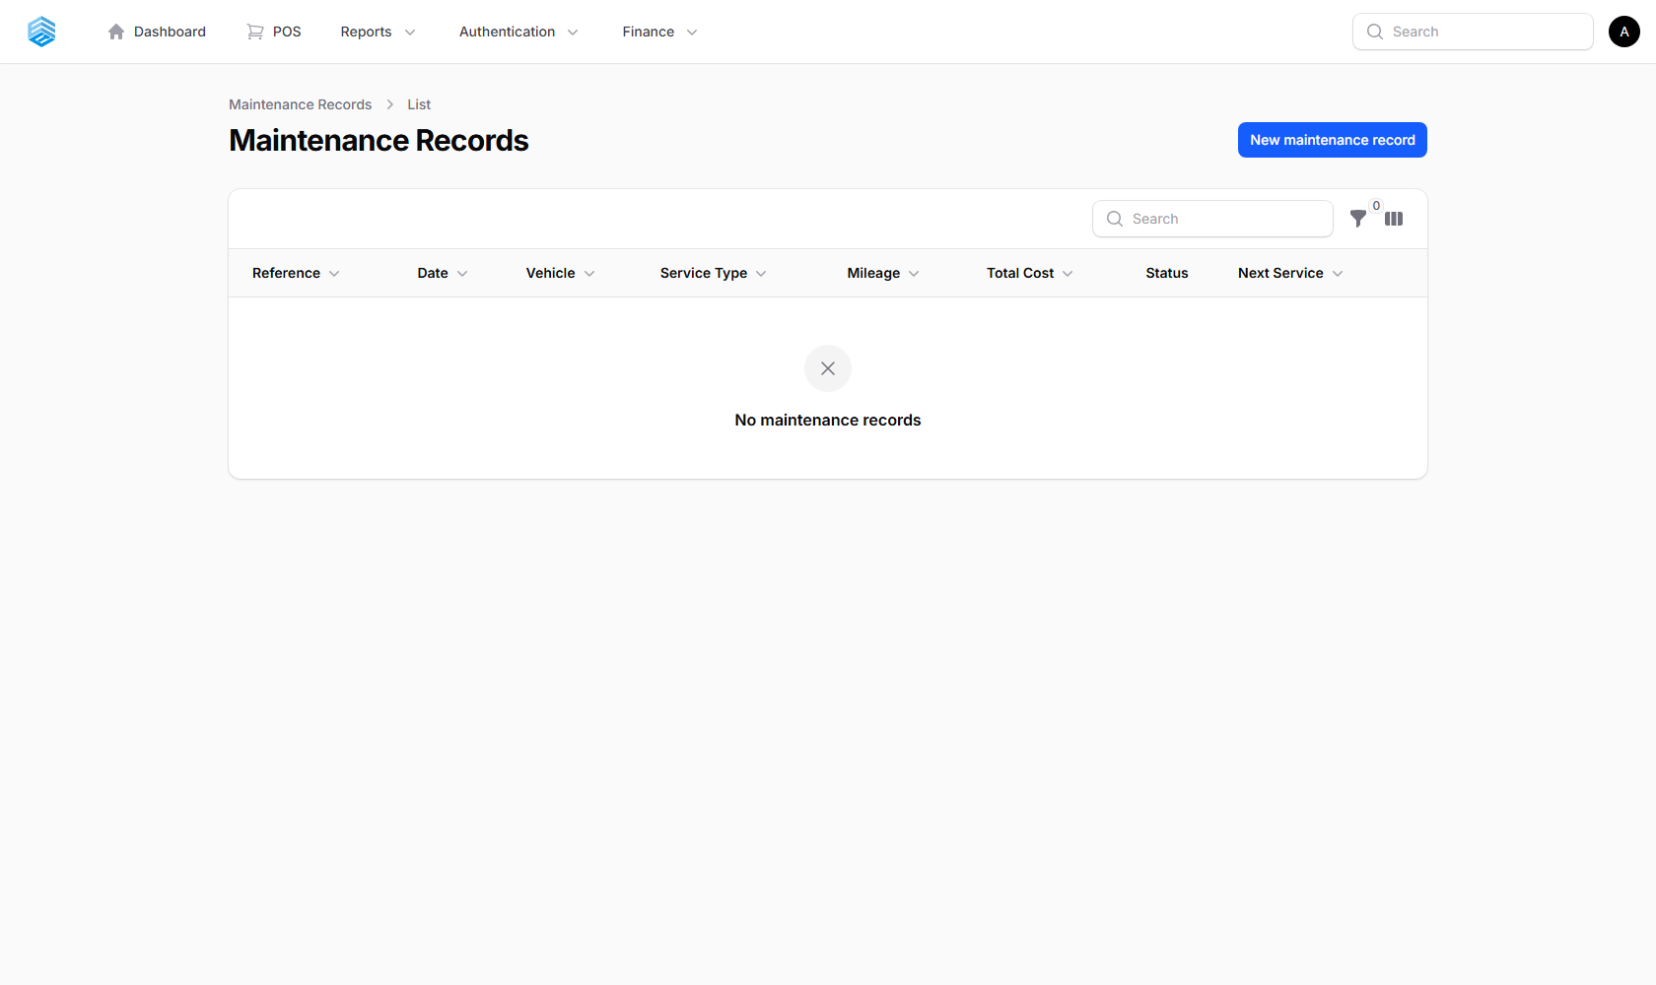
Figure 23. The Maintenance Records list.

Key Fields
Field | Description
Parts Cost + Labor Cost | Combine into the record’s Total Cost
Next Service Date / Next Service Mileage | Used to flag the vehicle as due for maintenance
Invoice Upload | Attach the service provider’s invoice

7.4 Maintenance Requests (Service Requests)
Staff submit a service request for a vehicle; it goes through an approval workflow before becoming a Maintenance Record.
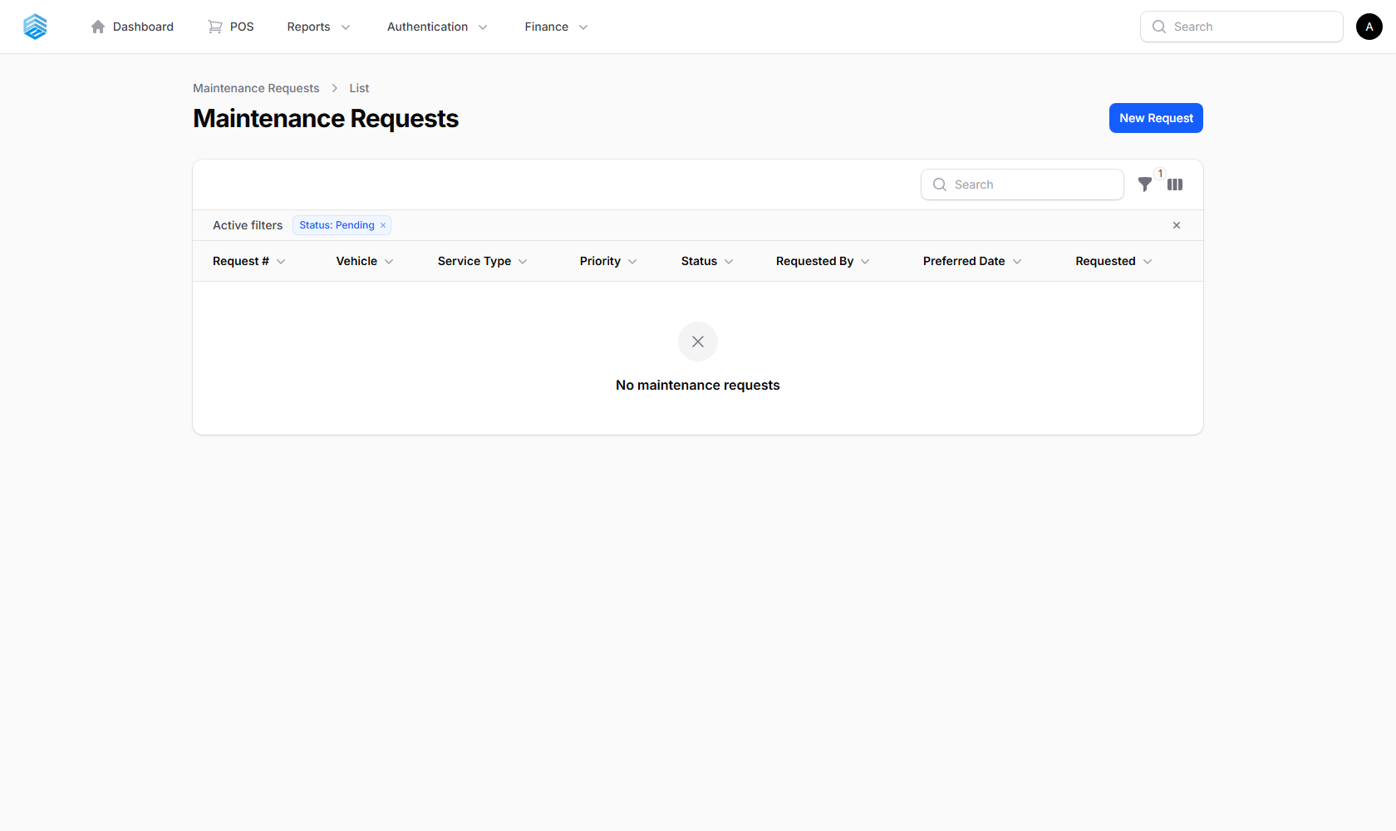
Figure 24. The Maintenance Requests list.

Submitting a Request
- Click New request.
- Select the Vehicle and Maintenance Type.
- Describe the issue and set a Priority (Low / Normal / High).
- Click Create.

Statuses
Status | Meaning
Pending | Awaiting review
Approved | Approved, with an estimated cost — ready to be actioned
Rejected | Declined, with a rejection reason recorded
Completed | Linked to the resulting Maintenance Record

ℹ A badge on the Home card shows the current count of pending requests awaiting approval.

8. Attendance Management
Employee time tracking, leave management, and biometric device integration.

8.1 My Attendance
Every employee has access to their own My Attendance page to clock in, clock out, and review their attendance history — no admin access required.
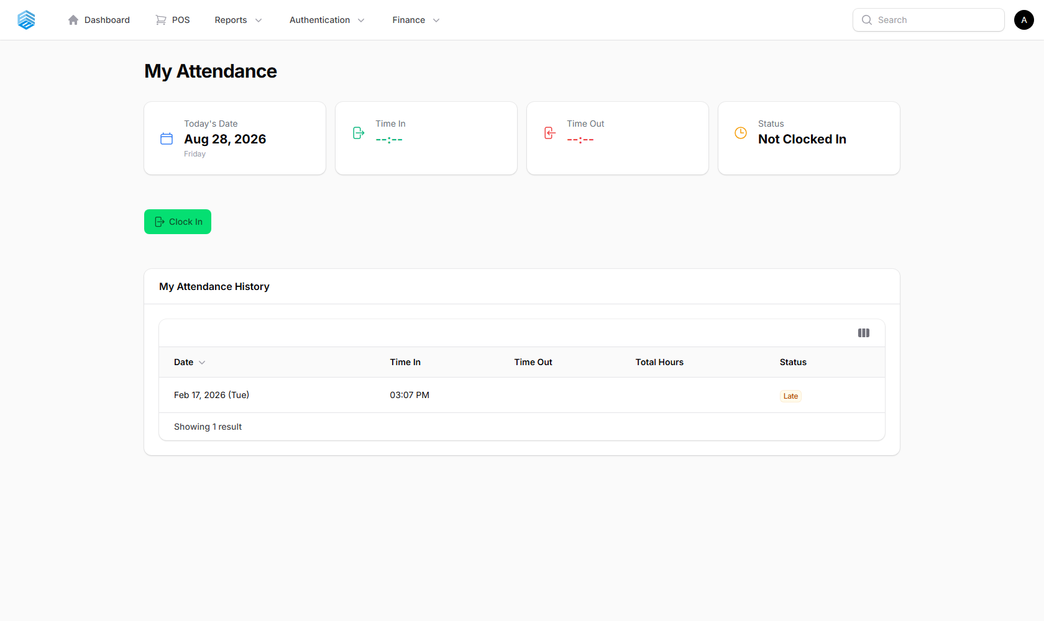
Figure 25. The My Attendance self-service page.

8.2 Attendance
Administrators and supervisors can view and manage attendance logs for every employee here.
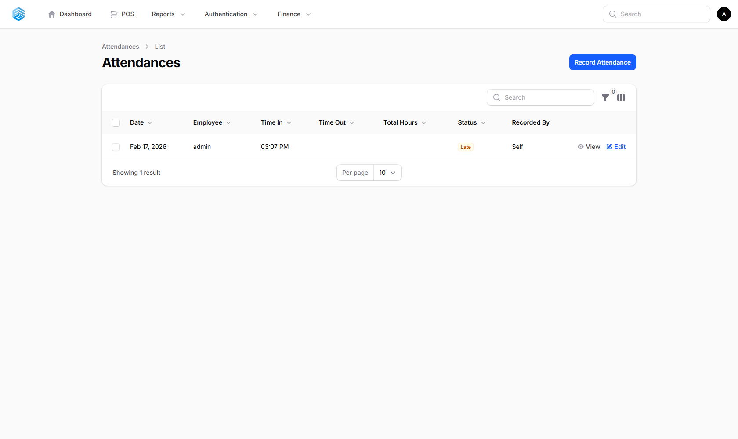
Figure 26. The company-wide Attendance list.

Statuses
Status | Meaning
Present (green) | Clocked in and out as expected
Absent (red) | No attendance recorded for the day
Late (yellow) | Clocked in after the expected time
Half Day (blue) | Worked only part of the day
On Leave (gray) | Covered by an approved leave request

ℹ **Total Hours** is calculated automatically from Time In and Time Out. Filter by status, employee, or date range.

8.3 Employees
Employee records — every system user can also be an employee, linked to their attendance, leave, compensation, and payroll history.

Figure 27. The Employees list.

Adding an Employee
- Click New employee.
- Enter the employee’s details, including their biometric PIN (for ZKTeco devices) and login credentials if they need system access.
- Click Create.

Figure 28. The Create Employee form.

8.4 Biometric Devices
Register and monitor ZKTeco biometric time-clock terminals. Devices push attendance events (finger-print or face clock-ins) directly into the Attendance module — no manual entry required at sites with a registered device.

Figure 29. The Biometric Devices list.

8.5 Leave Types
Configure the leave categories available to employees (e.g. Sick Leave, Vacation Leave), each with an annual day entitlement and whether it is paid.
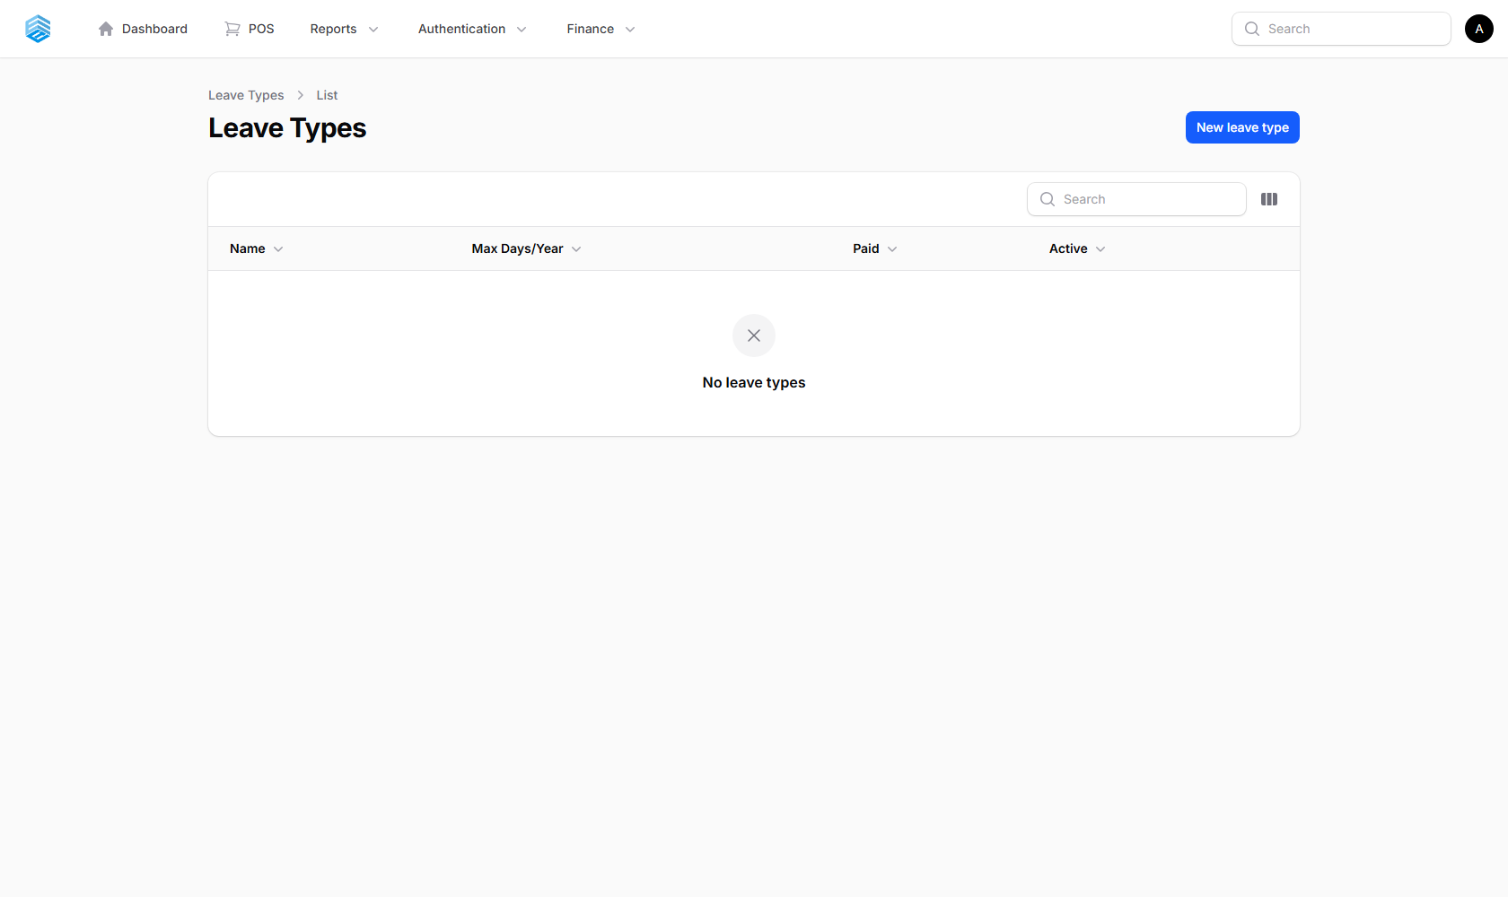
Figure 30. The Leave Types list.

8.6 Leave Requests
Employees submit leave requests, which go through an approval workflow.
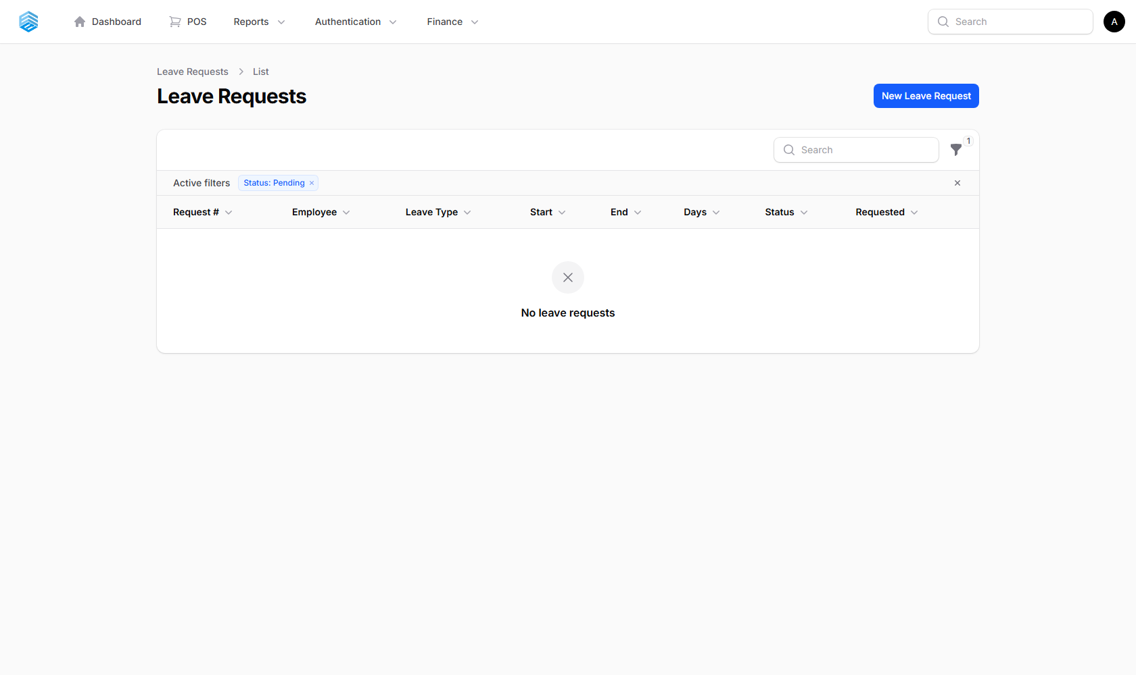
Figure 31. The Leave Requests list.

Statuses
Status | Meaning
Pending | Awaiting a decision
Approved | Approved — total days are deducted from the entitlement
Rejected | Declined, with a reason recorded
Cancelled | Withdrawn by the employee or an admin

ℹ A badge on the Home card shows the current count of pending leave requests.

9. Payroll
Process payroll runs and manage the compensation setup behind them.

9.1 Payrolls
Each payroll run covers a pay period (Daily, Weekly, or Semi-Monthly) and follows a Draft → Approved → Paid workflow. Individual employee pay lines (gross pay, deductions, net pay) are managed inside each payroll record.
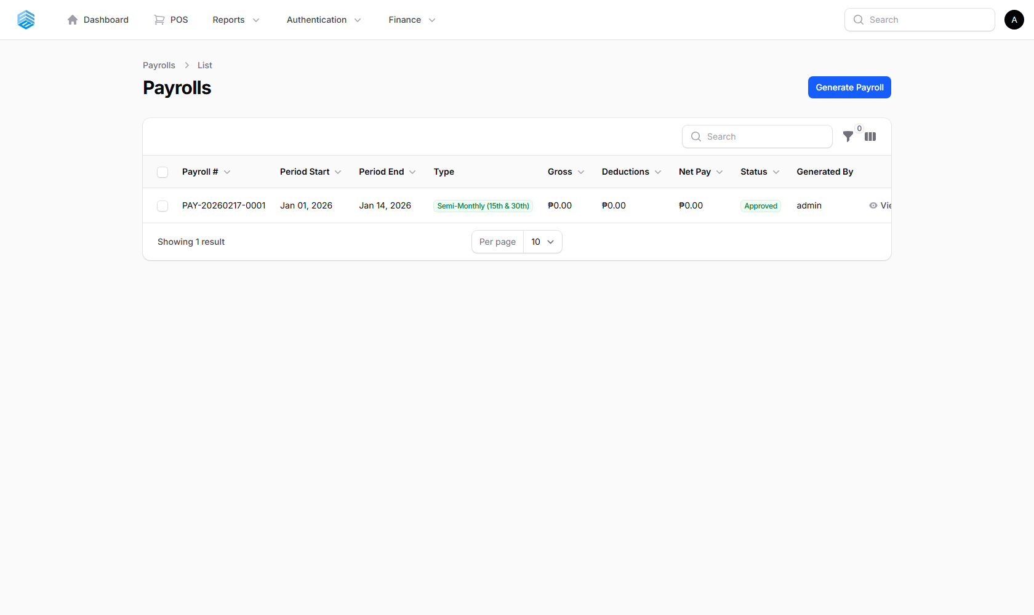
Figure 32. The Payrolls list.

Statuses
Status | Meaning
Draft | Being prepared — can still be edited
Approved | Reviewed and approved — ready to be paid
Paid | Payment has been released
Cancelled | Voided — not possible once Paid

ℹ A badge on the Home card shows the count of draft payrolls awaiting approval. Each payroll can be exported as a PDF payslip.

9.2 Employee Compensation
The salary and compensation setup for each employee — the source figures a payroll run pulls from when calculating gross pay.
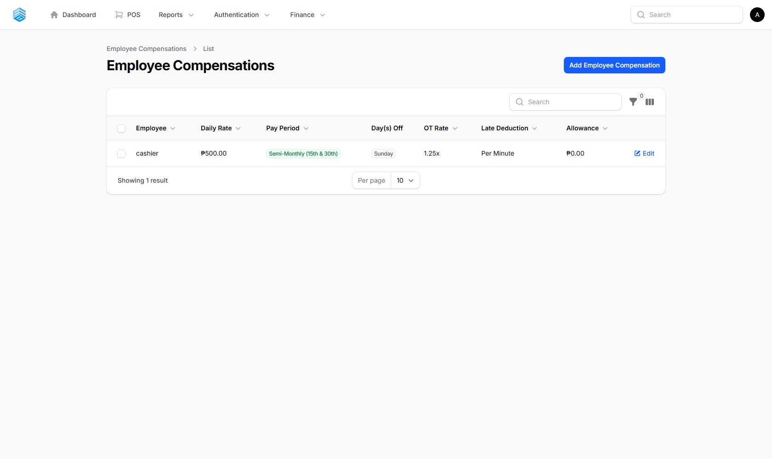
Figure 33. The Employee Compensation list.

9.3 Government Contributions
Configure statutory deduction tables — SSS, PhilHealth, and Pag-IBIG — used to calculate mandatory deductions during payroll processing.
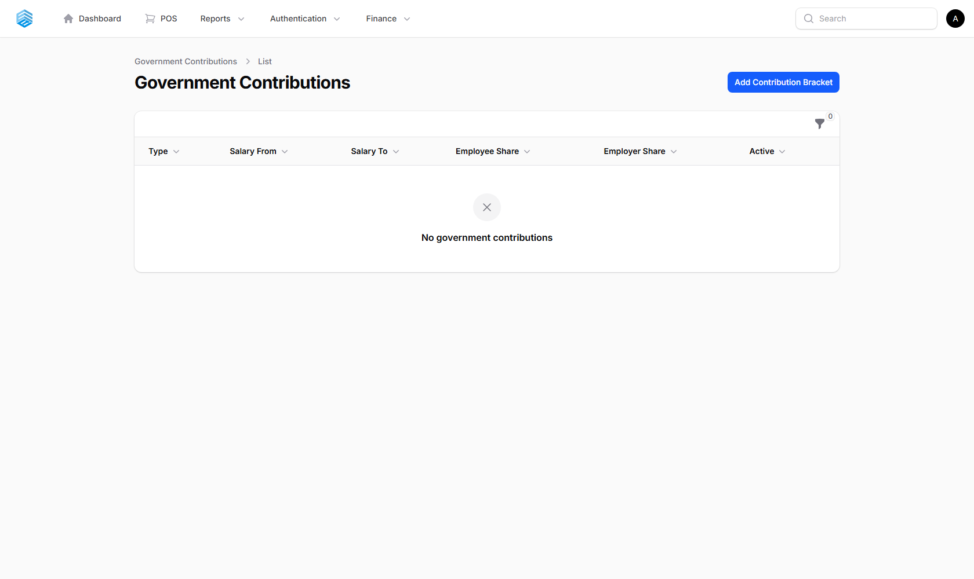
Figure 34. The Government Contributions list.

10. Finance
Track spending, and monitor overall financial performance.

10.1 Expenses
Record every business expense — utilities, rent, supplies, vehicle maintenance, salaries, and more.
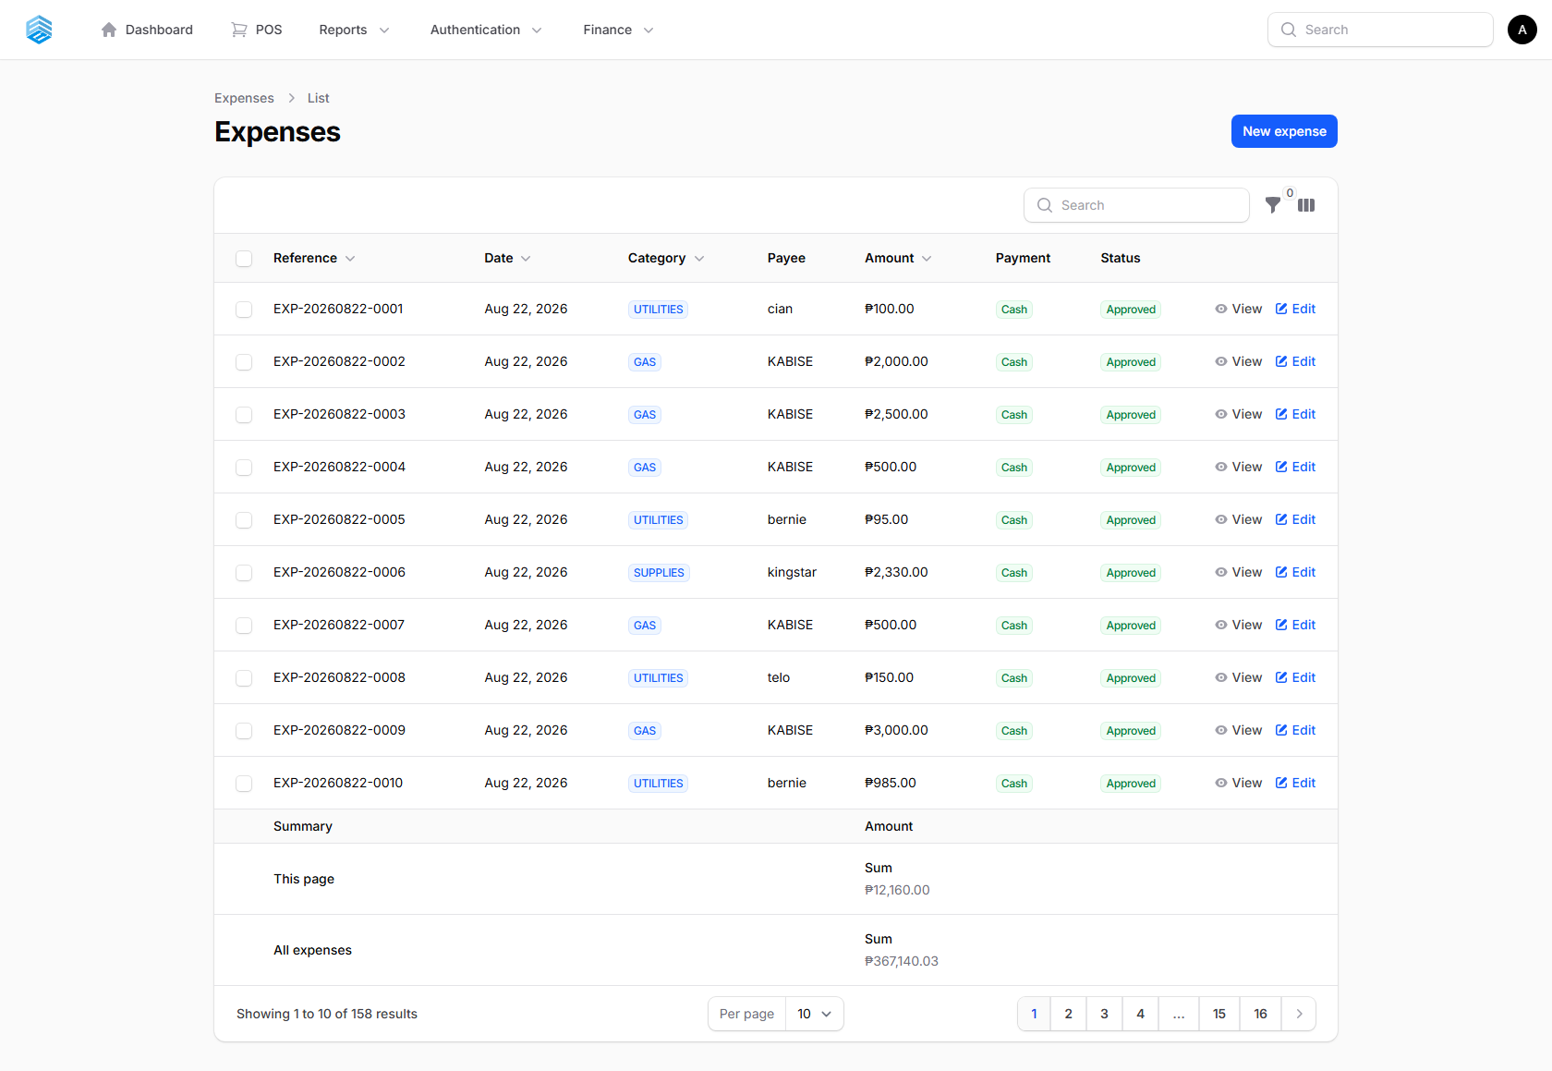
Figure 35. The Expenses list.

Recording an Expense
- Click New expense.
- Select the Category, enter the Amount, Payee, and a Description.
- Set the Expense Date (cannot be a future date) and payment method.
- Optionally attach a Receipt (image or PDF, max 5 MB).
- Click Create.
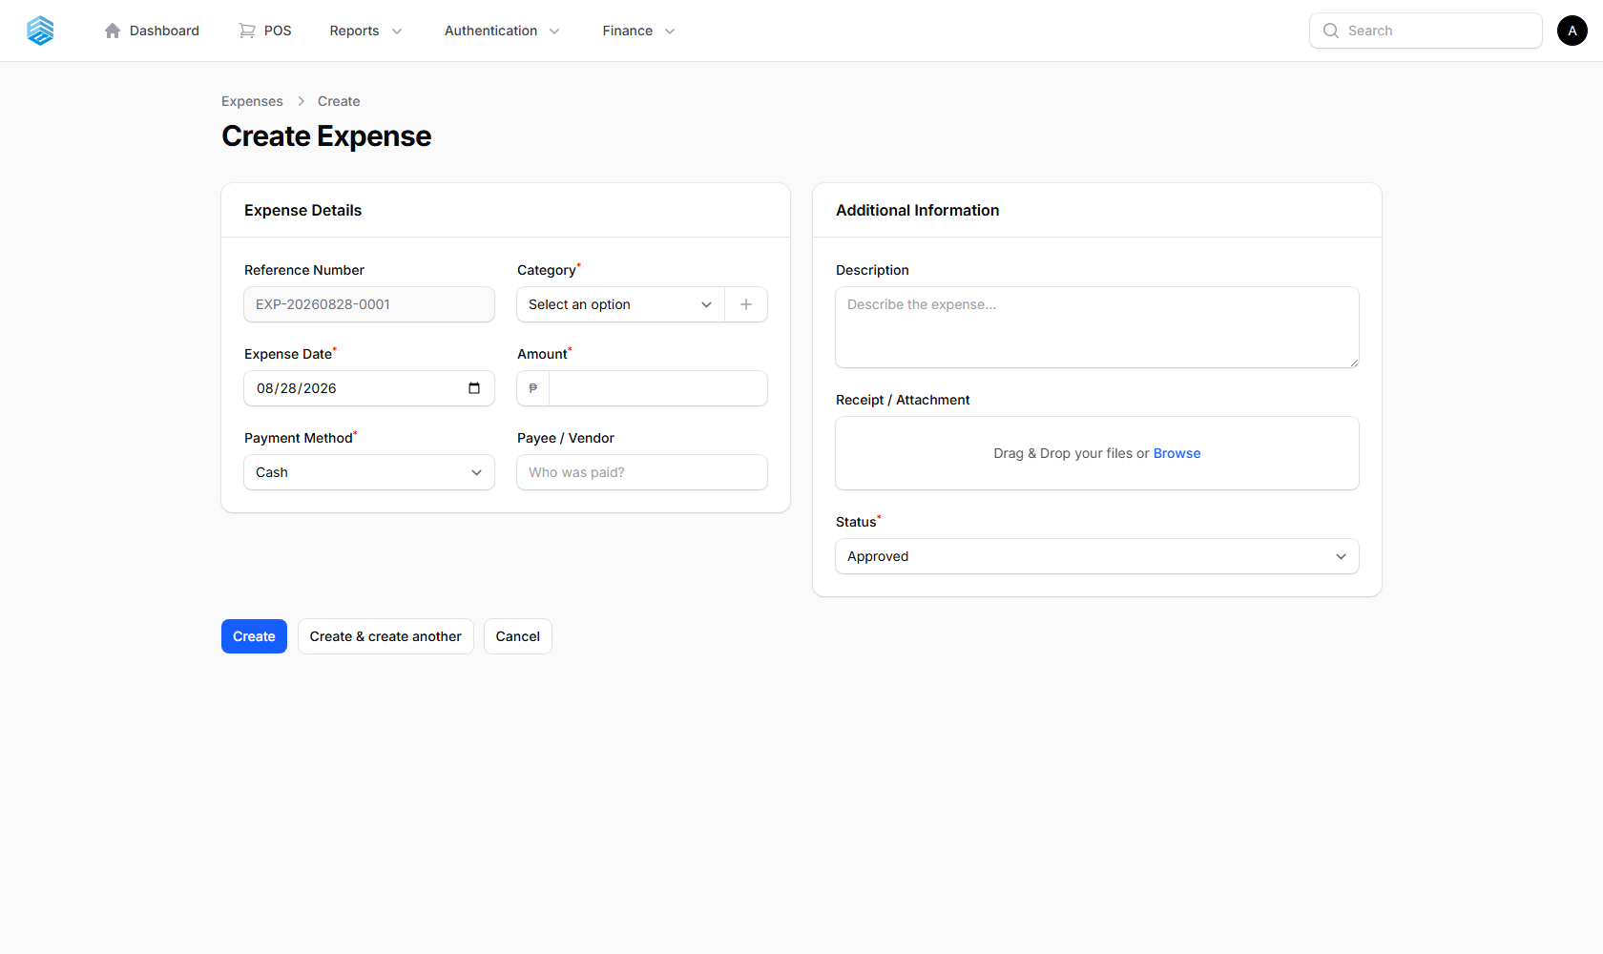
Figure 36. The Create Expense form.

Key Fields
Field | Description
Reference Number | Auto-generated, format EXP-YYYYMMDD-XXXX
Status | pending / approved / rejected (defaults to approved)

ℹ Only **approved** expenses are counted in financial totals and the Profit & Loss report.

10.2 Expense Categories
Create and manage expense categories (Utilities, Rent, Supplies, Transportation, Salaries, Marketing, Maintenance, etc.) to keep spending organised. Each category shows its running total.
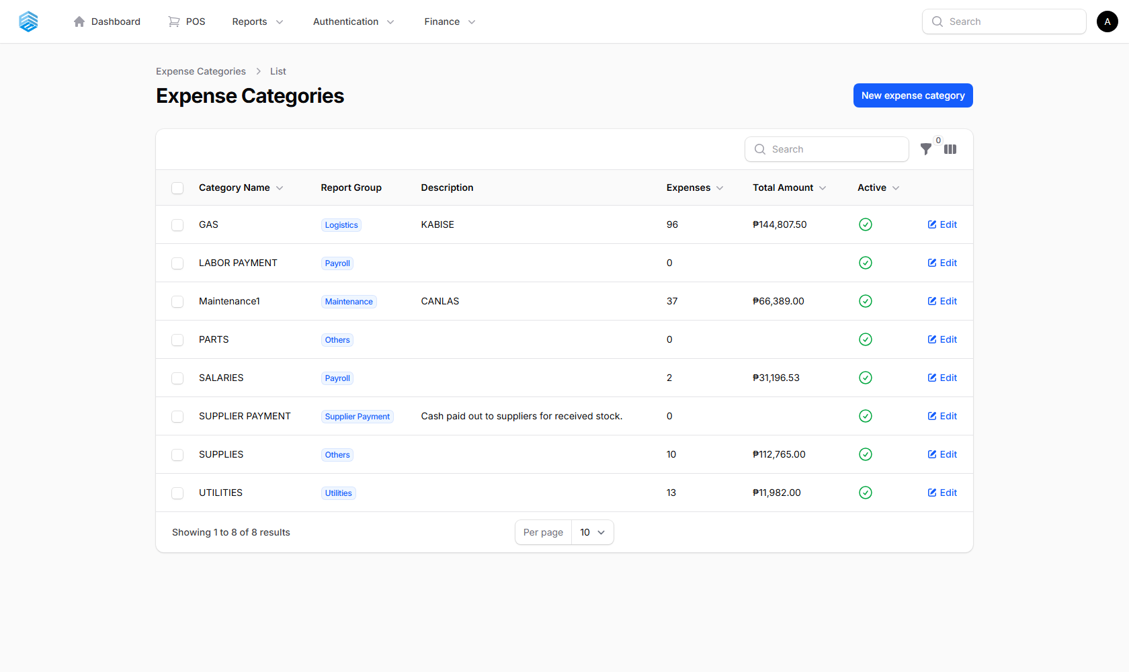
Figure 37. The Expense Categories list.

10.3 Financial Dashboard
A comprehensive financial overview for any period.
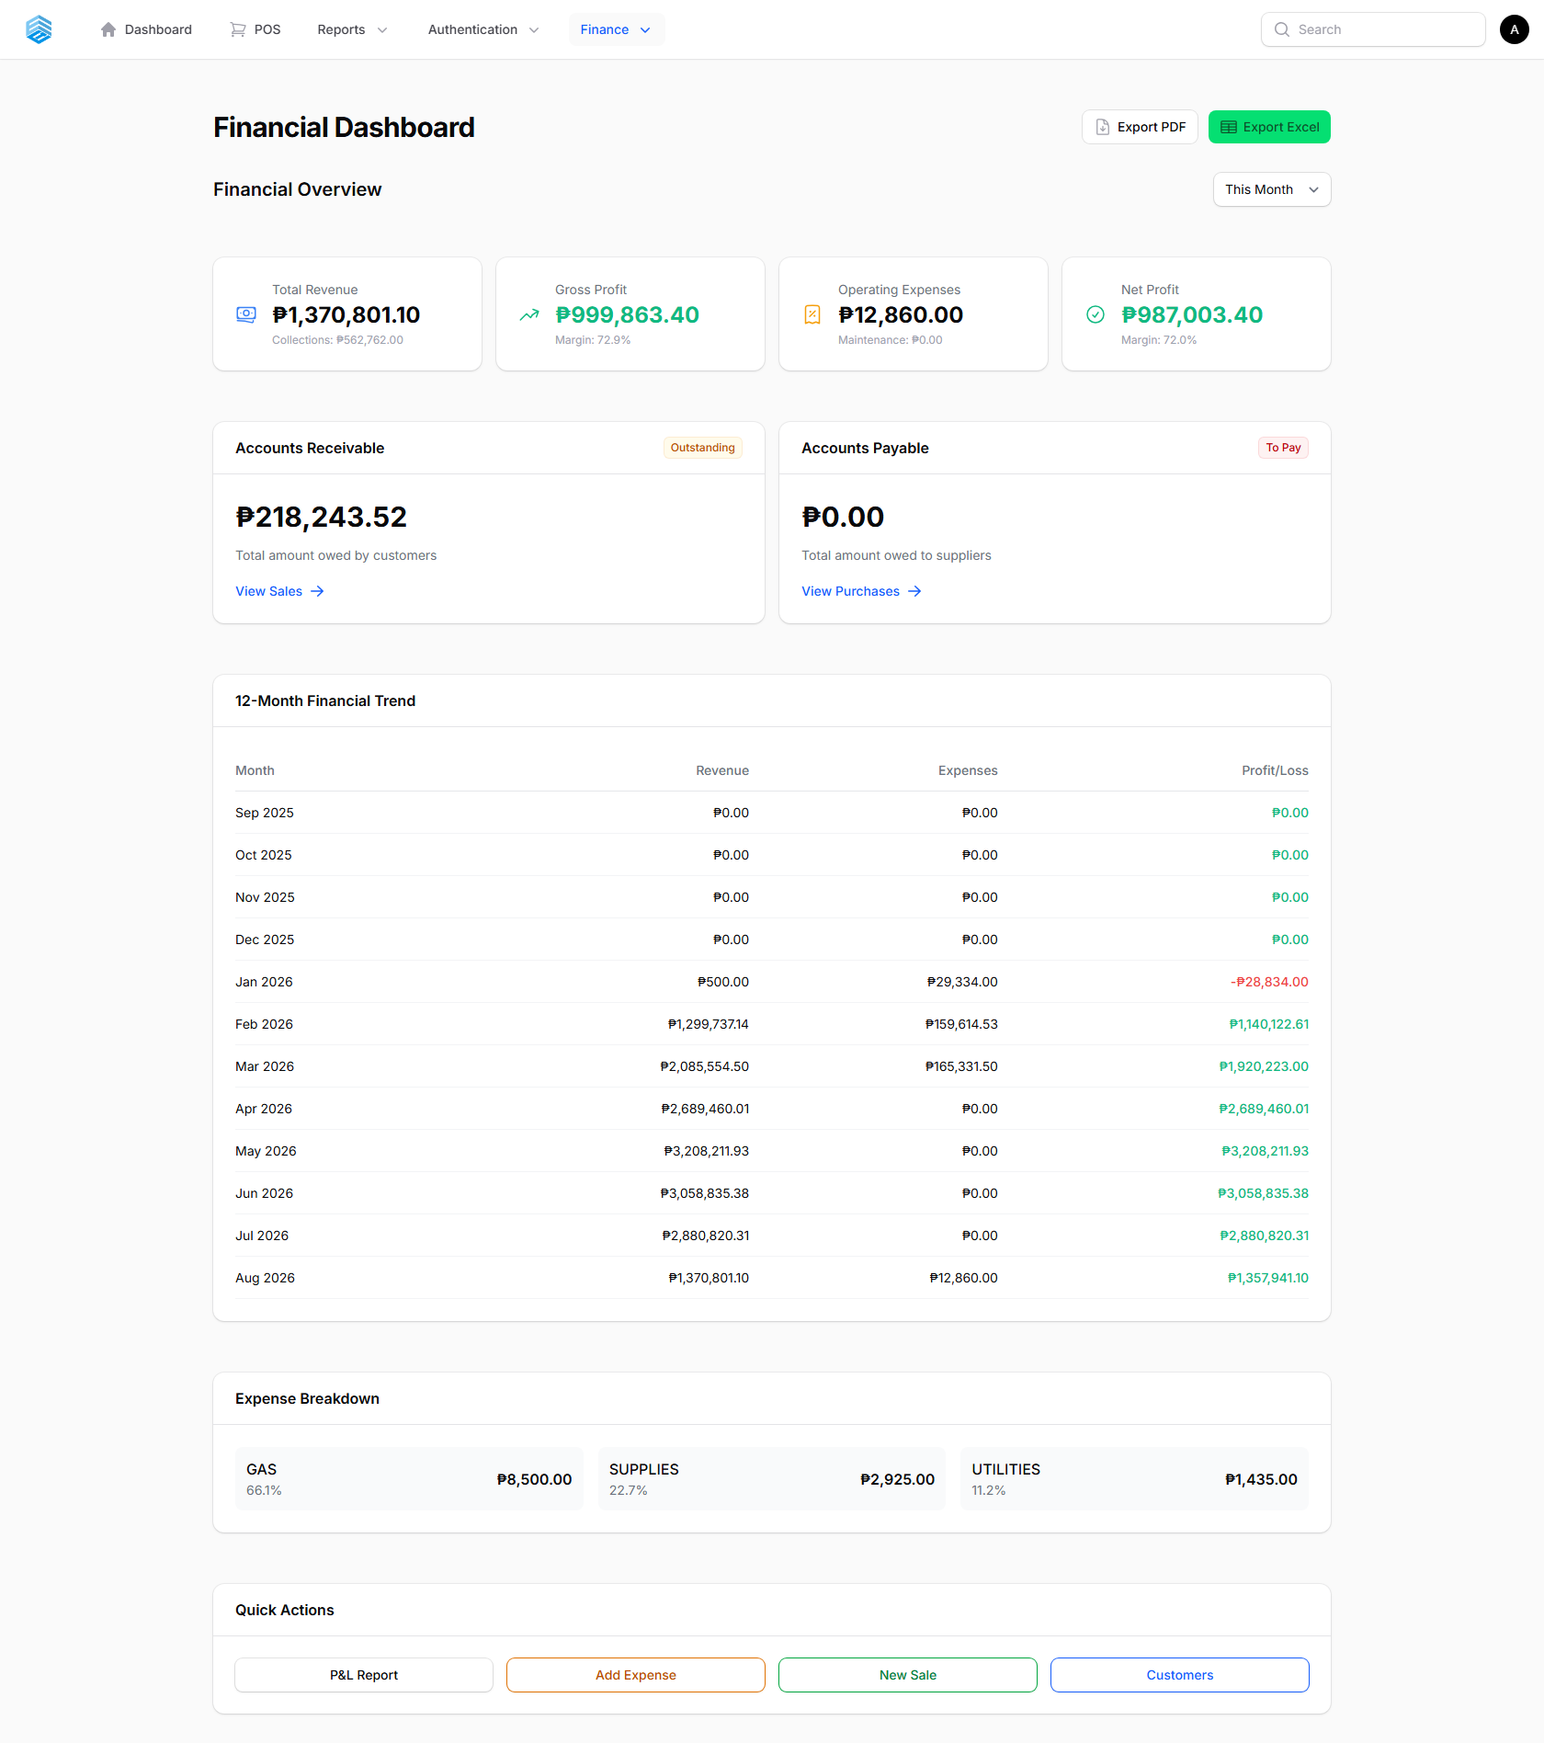
Figure 38. The Financial Dashboard.

Choosing a Period
- Select Today, This Week, This Month, This Year, or a Custom Date Range.
- Review the expense breakdown by category.
- Use Export to PDF or Export to Excel to download the report.

Key Fields
Field | Description
Total Revenue | Income from sales in the selected period
Total Expenses | All approved expenses in the period
Gross Profit | Revenue minus cost of goods sold (COGS)
Net Profit | Gross profit minus operating expenses

10.4 Profit & Loss
A detailed profit and loss statement: revenue breakdown, cost of goods sold, gross margin, operating expenses by category, and net income for the selected period.
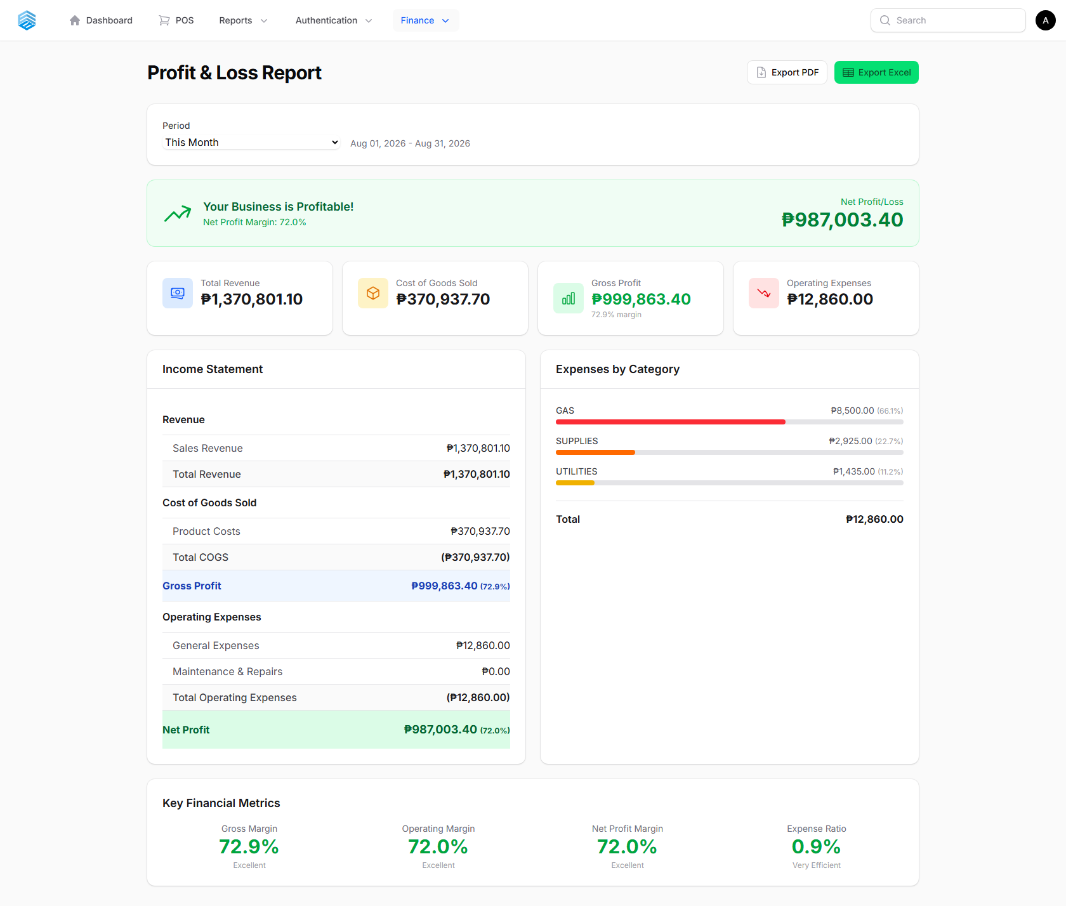
Figure 39. The Profit & Loss report.

11. Reports
All analytical and export-focused reports live under Reports in the top nav or as cards on the Home screen. Most reports support a date-range filter and CSV / Excel / PDF export.

11.1 Daily Transaction Report
A day-by-day breakdown of transactions processed through the POS — useful for a quick daily reconciliation.
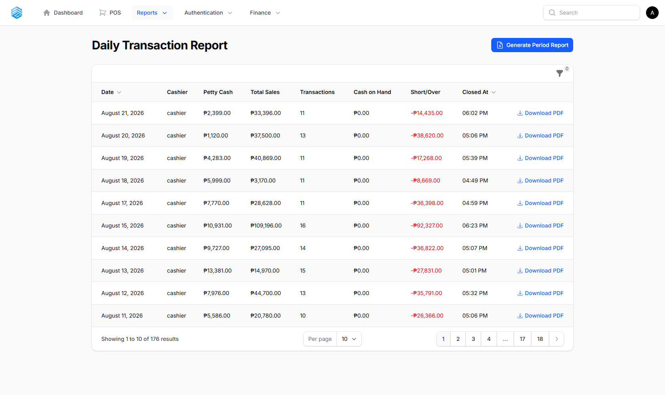
Figure 40. The Daily Transaction Report.

11.2 Sales Report
Comprehensive sales analysis filterable by period (Today, Week, Month, Year, or a custom range) and viewable by customer. Export to CSV for further analysis.
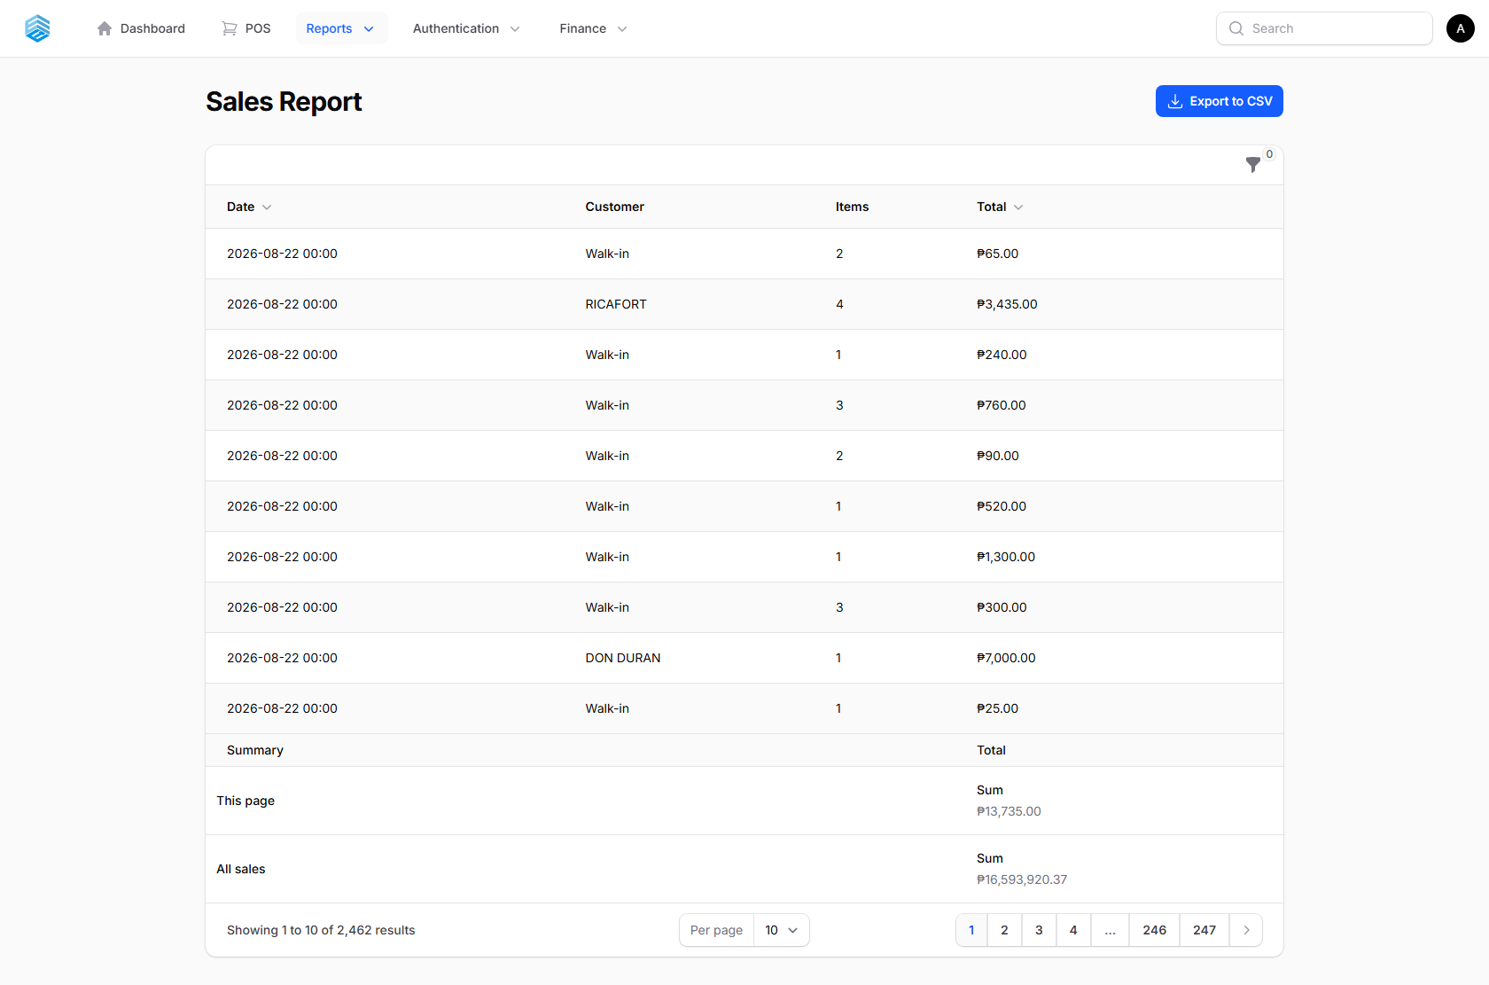
Figure 41. The Sales Report.

11.3 Inventory In/Out Report
Tracks every inventory movement — stock added from purchases, stock sold, and manual adjustments — exportable to CSV.
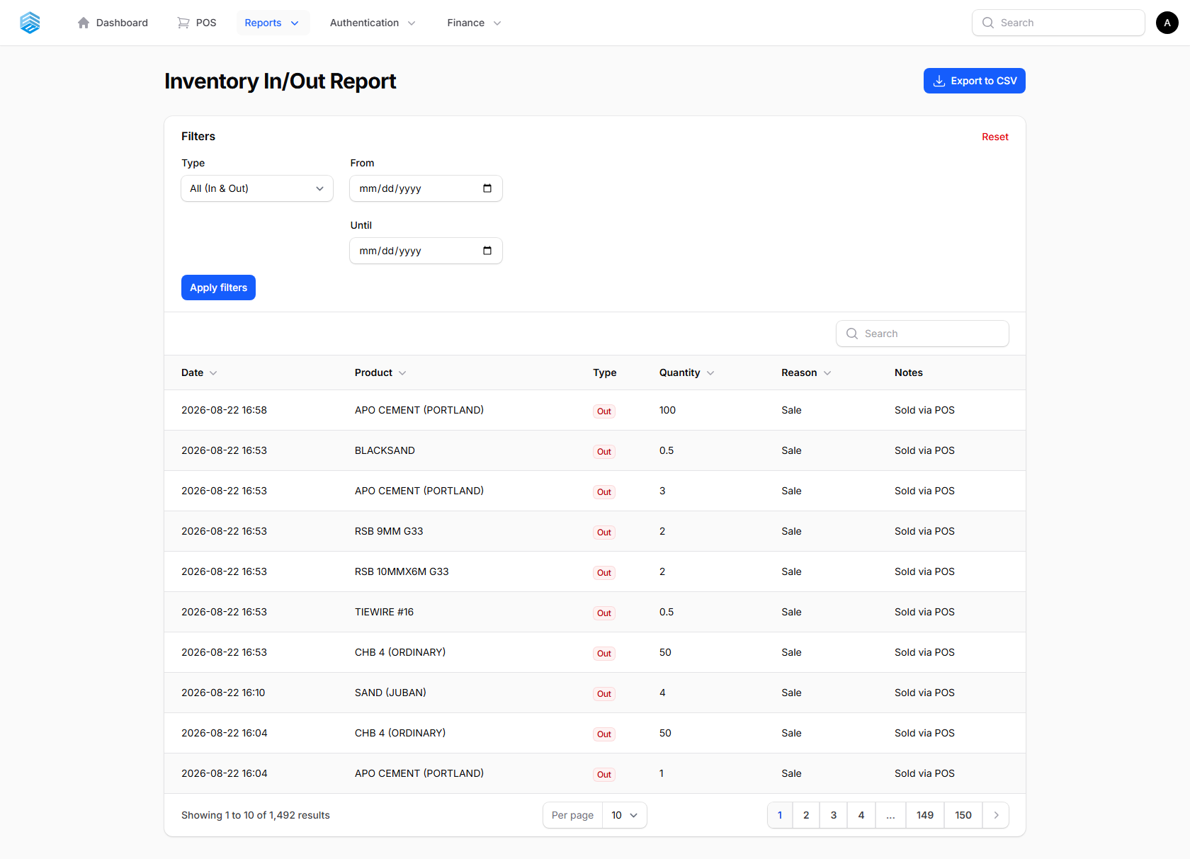
Figure 42. The Inventory In/Out Report.

11.4 Products Report
Product performance analysis, filterable by category and supplier, with current stock levels.
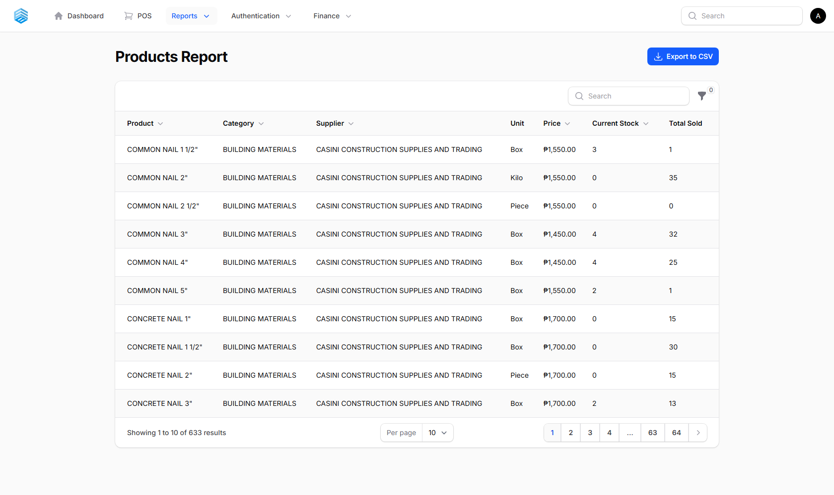
Figure 43. The Products Report.

11.5 Supplier Price Comparison
Compares what each supplier charges for the same product, using the base prices recorded on the product record (Section 5.1) — helpful when deciding who to purchase from.
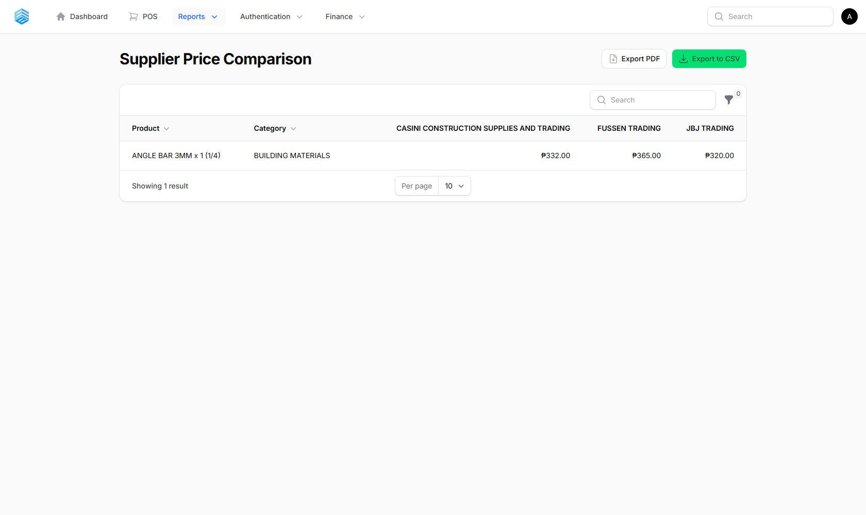
Figure 44. The Supplier Price Comparison Report.

11.6 Driver KPI Dashboard
Delivery driver performance at a glance.
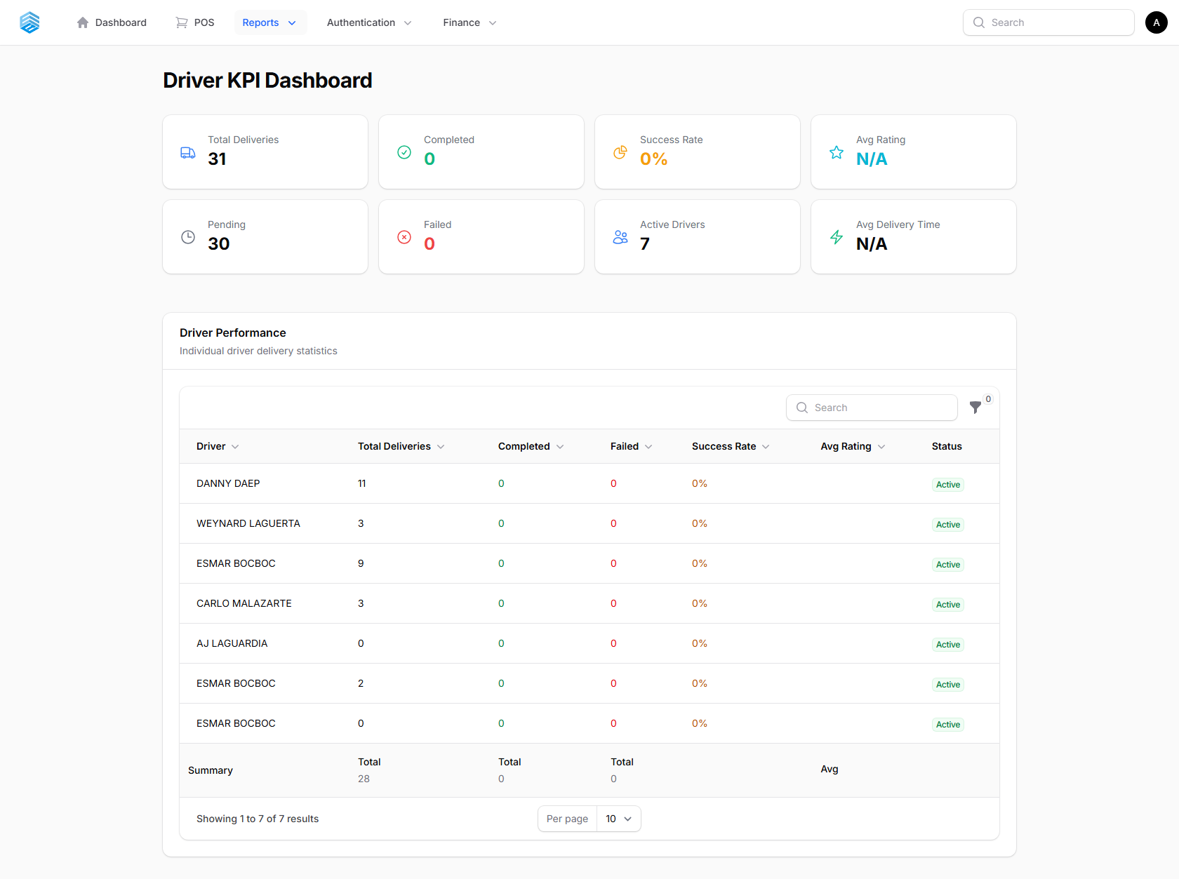
Figure 45. The Driver KPI Dashboard.

Key Fields
Field | Description
Total / Successful / Failed Deliveries | Delivery counts by outcome
On-time Rate | Percentage of deliveries completed on schedule
Average Delivery Time | Average time from pickup to delivery

11.7 Aging Report
Tracks overdue payments in both directions.
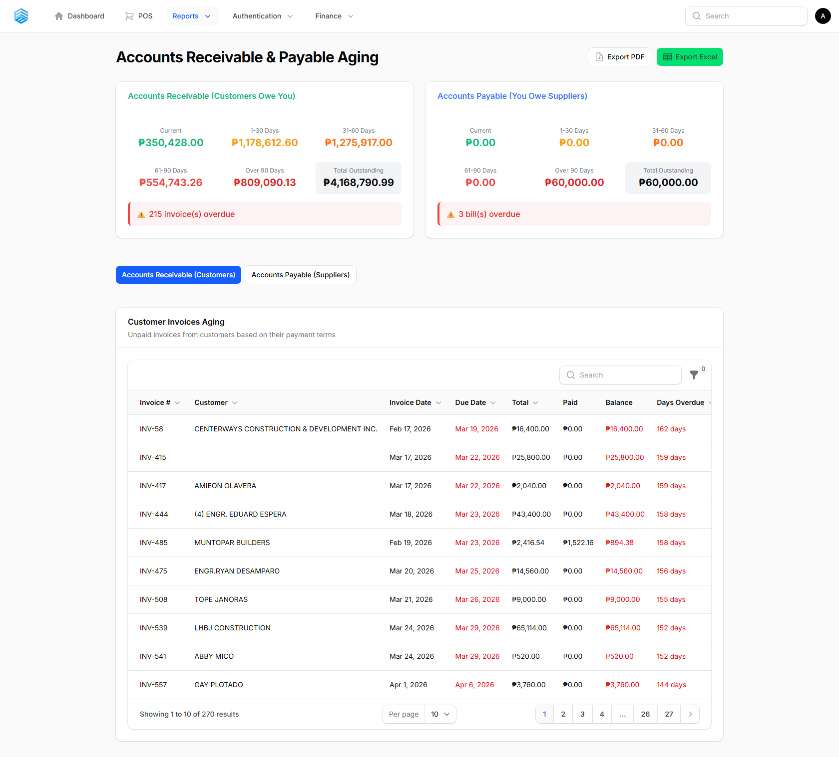
Figure 46. The Aging Report.

Key Fields
Field | Description
Accounts Receivable | Money owed TO you by customers
Accounts Payable | Money YOU owe to suppliers

Statuses
Status | Meaning
Current | Not yet due
1–30 Days | Overdue by 1 to 30 days
31–60 Days | Overdue by 31 to 60 days
61–90 Days | Overdue by 61 to 90 days
Over 90 Days | Overdue by more than 90 days

ℹ Export to Excel or PDF for follow-up with customers or suppliers.

12. Authentication & Security
User accounts, access control, and a full audit trail of system activity.

12.1 Users
Manage system users — add new users, edit user information, reset passwords, and assign roles.
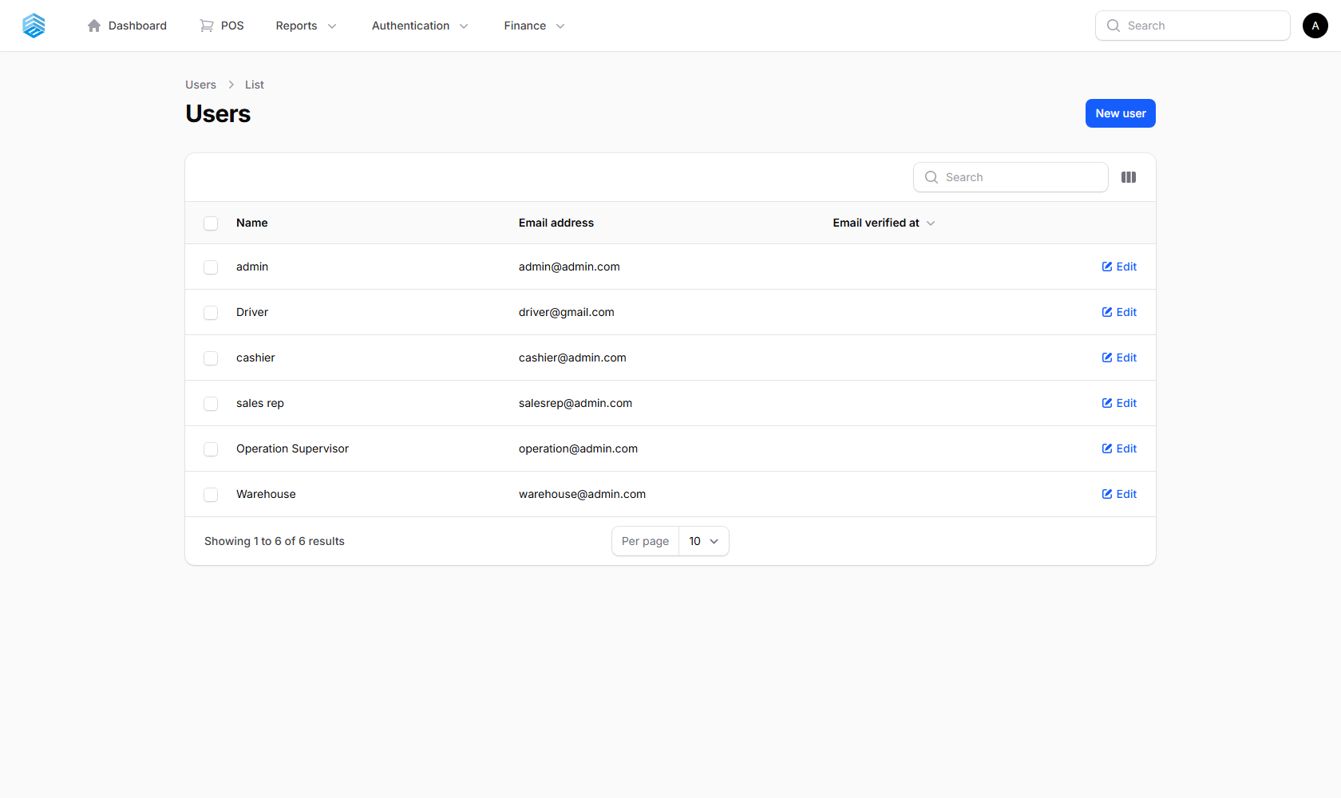
Figure 47. The User Management list.

ℹ Every user also functions as an employee, linked to Attendance, Leave Requests, Compensation, and Payroll records (Section 8 and 9).

12.2 Roles & Permissions
Roles control exactly which modules and actions each user can access. Every module exposes granular View / Create / Edit / Delete permissions that can be assigned to any role.
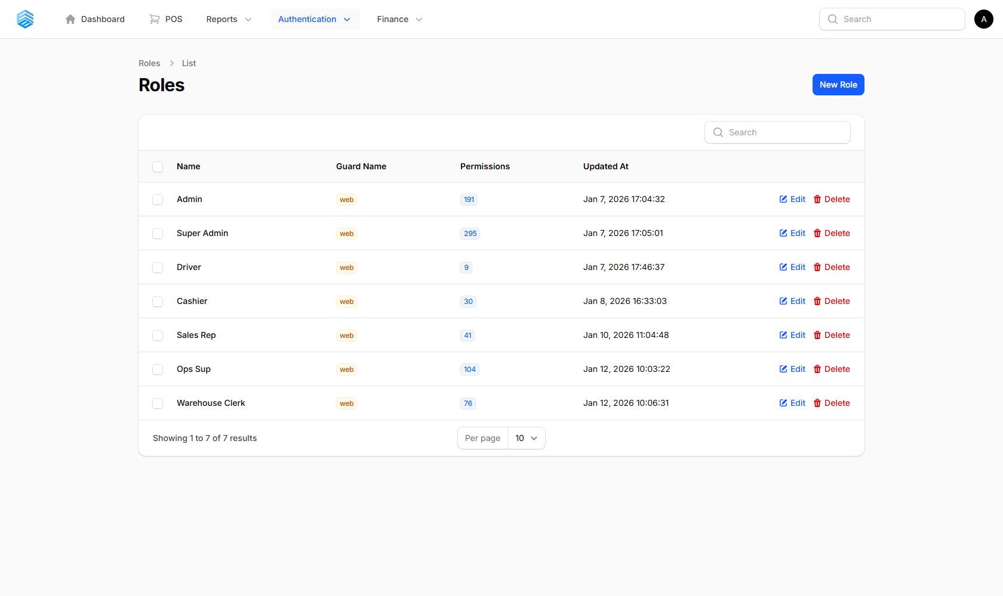
Figure 48. The Roles & Permissions list.

ℹ A notable custom permission, **approve_quotation**, controls who can approve or reject quotations and receive the related email notifications (Section 4.9).

12.3 Audit Logs
A complete, read-only trail of significant actions across the system — who did what, and when.
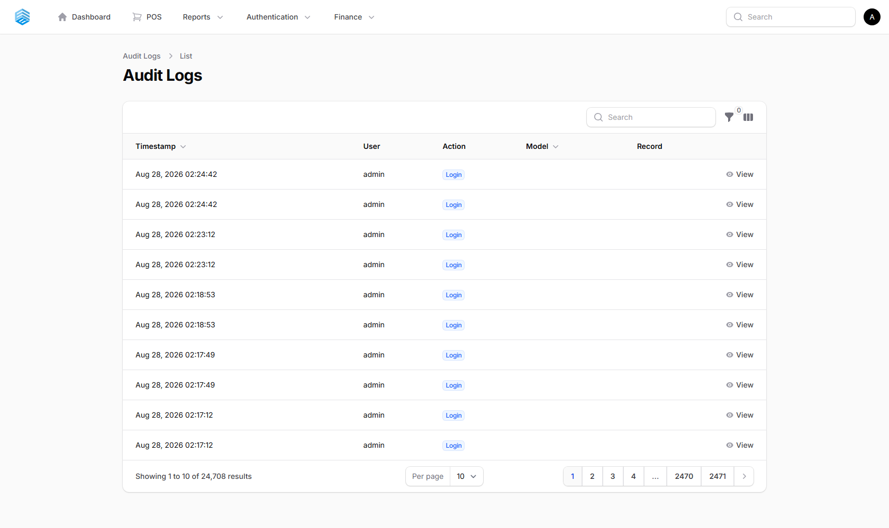
Figure 49. The Audit Logs list.

Key Fields
Field | Description
Action | e.g. completed_sale, approved, opened_register
Old Values / New Values | The record’s field values before and after the change
IP Address / User Agent | Where the action came from

ℹ Audit logs cannot be edited or deleted from the interface, and sensitive fields (passwords, tokens) are always excluded.

13. Tips & Best Practices

13.1 Daily Operations
Start of day: log in, check the Dashboard for alerts, review overdue payments (Aging Report), and check low-stock items.
During the day: process sales through the POS, record expenses immediately, and keep delivery statuses up to date.
End of day: review daily sales (Sales Report / Daily Transaction Report), confirm all deliveries are updated, and close the cash register.

13.2 Inventory
- Record every stock addition as a Purchase — never edit stock levels manually.
- Check physical stock against the system regularly.
- Keep products categorised for faster POS browsing.

13.3 Finance
- Record expenses daily — do not let them pile up.
- Use the correct expense category for accurate Profit & Loss reporting.
- Review the Financial Dashboard and P&L weekly.
- Follow up on receivables using the Aging Report.

13.4 Customers & Credit
- Collect full contact details for every customer.
- Set payment terms explicitly and be clear about payment expectations.
- Use Quotations for large orders before committing to a sale.
- Never apply payment terms to a cash sale.

13.5 Fleet, Delivery & HR
- Follow recommended maintenance intervals — the system flags overdue vehicles automatically.
- Keep vehicle mileage updated after every trip or service.
- Use the Driver KPI dashboard for accountability and route planning.
- Approve leave requests and maintenance requests promptly to avoid a growing backlog.

14. Appendix — Reference Number Formats
Every auto-generated document number follows the same pattern and resets daily.
Record | Format | Example
Quotation | QT-YYYYMMDD-XXXX | QT-20260220-0001
Expense | EXP-YYYYMMDD-XXXX | EXP-20260220-0001
Maintenance Record | MNT-YYYYMMDD-XXXX | MNT-20260220-0001
Maintenance Request | REQ-YYYYMMDD-XXXX | REQ-20260220-0001
Leave Request | LR-YYYYMMDD-XXXX | LR-20260220-0001
Payroll | PAY-YYYYMMDD-XXXX | PAY-20260220-0001

Getting Help
- Check this user guide first.
- Contact your system administrator.
- Report bugs or issues through the proper support channel.

Tri-E Trading Operating System (TOS) — Complete User Guide
Built with Laravel 12, Filament v4, and Livewire v3
Documentation Version 2.0 · August 2026

